Chapter IV
Results and Discussion

With time, availability of fossil fuels, especially crude oil is decreasing and this fact needs considerable attention of the world to search for an alternative. Ethanol is very popular as a beverage since ancient time, but it also has wide range of applications, i.e., as a solvent, chemical intermediate, in medicine and as a furl. Biomass utilization is the immediate solution in which most of the solar energy is trapped in the form of reserve materials. These raw materials are carbohydrates, which may be categorized into sugars, starch and cellulose. Cellulose is the most abundant carbohydrate on earth and next comes the starch. Cellulose materials require acid or enzyme hydrolysis using cellulose. The extraction of cellulose requires chemical reagents and the cellulosic extract has to be later hydrolyzed by the enzyme. This process not only releases toxic effluence, but it is also costly.
Starch is present in the storage parts of plants. Cereal grains are one of the major sources of starch. From table 2.1 it is evitable that millets yield high amounts of fermentable sugars. The starch in the pearl millet seeds can be hydrolyzed using amylases from its malt. The entire process is non-toxic as the millet flour can be directly as substrate and high protein content of the seeds provide most of the nitrogen required by the organism. Germinated seeds provide enzymes required for starch and protein hydrolysis, which include amylases and proteases. The resulting sugars can be directly used for ethanol production.

4.1 Malting studies
The two pearl millet varieties selected for studying i.e., the Hybrid Bajra variety KMBH-9, and the normal variety available in the local market subjected for malting separately. Malting involves steeping, germination and kilning.
4.1.1 Steeping studies
Initially the seeds were subjected to sodium hypochlorite treatment for 15 minutes. The chlorine helps in sterilizing the surface of the seeds. The effect of this treatment on the water inhibition by the seeds was monitored. After 15 minutes of exposure, the seeds were thoroughly cleaned was observed by keeping an untreated sample as control for both the varieties.
The results at the end of steeping for the untreated and treated samples for both the varieties are listed in Table 4.1. The hybrid seeds which are of larger size then the normal variety imbibed more water. The results finally indicate that hypochlorite treatment enhances the rate of imbibitions by the germinating seeds.

Table 4.1 Effect of Sodium hypochlorite treatment on hybrid seeds and normal seeds
Samples | Initial weight  (g) | Weight after 24h of steeping (g) | Moisture  %
Hybrid seeds
Control | 5 | 5.79 | 15.80
Untreated | 5 | 6.25 | 24.00
Treated | 5 | 6.30 | 26.0
Normal seeds
Control | 5 | 6.669 | 13.39
Untreated | 5 | 6.0695 | 21.39
Treated | 5 | 6.216 | 24.32

The change in the moisture content of the hybrid seeds during steeping was monitored for a period of 48h. Figure 4.1 indicates that there is a steady increase till 12h and from then onwards the rate of imbibition has reduced and it again increased later. By the end of 48h, the seeds started sprouting and the desprouted seeds showed 38% moisture content. During the first 12h around 53.9% of the total moisture was imbibed and by 24h it was around 68.42%. In barley grains around 60% of the total water was reported to be absorbed in the first 8 and 10h of steeping ( Kopecky and Almendinger, 1935). An optimal time of 24h was selected for steeping which resulted in 26% moisture content.
4.2 Germination
The seeds after 24h of steeping were removed, washed and spread as that layer on a filter paper in a tray. The tray was kept in a BOD incubator at 28ºC in the presence of light. Water was sprinkled at 28ºC in the presence of light. Water was sprinkled at regular time intervals to keep the seeds wet.
4.2.1 Effect of Gibberlic Acid
To study the effect of gibberlic acid, water containing 1ppm of GA₃ was used for sprinkling. Both the varieties were spread as two sets of which one is control (W) and the other is the treated one (GA). Samples were collected every 24h to monitor and labeled as GA1, W1 and GA2, W2 etc., based on the day the samples were collected. The changes in the physical characteristics such as, No. of sprouted seeds per gram of sample, weight of rootlets and shootlets (rtl + stl), weight of cotyledons, moisture content and dry weight of the seeds. Changes in the chemical composition i.e., starch, reducing sugars, protein, total amylases, α-amylases, β-amylases and proteases were measured.
4.2.2 Changes in the physical characteristics of seeds
The changes in the physical characteristics of both the seed varieties are listed in Table 4.2 and 4.3. Table 4.2 shows the results of hybrid seeds. As these seeds are larger in size, their number per gram is less when compared to normal seeds. The sprouted seeds number per gram decreases with time. Approximately 1.0 g of samples were weighed, the rootlets and the shootlets are carefully collected and weighed. The devegetated seeds were also weighed. With time the weight of rootlets and shootlets increase under both germination conditions (GA₃ treated and water treated) and the desprouted seeds weight decreases. The moisture content is also found to increase with time.
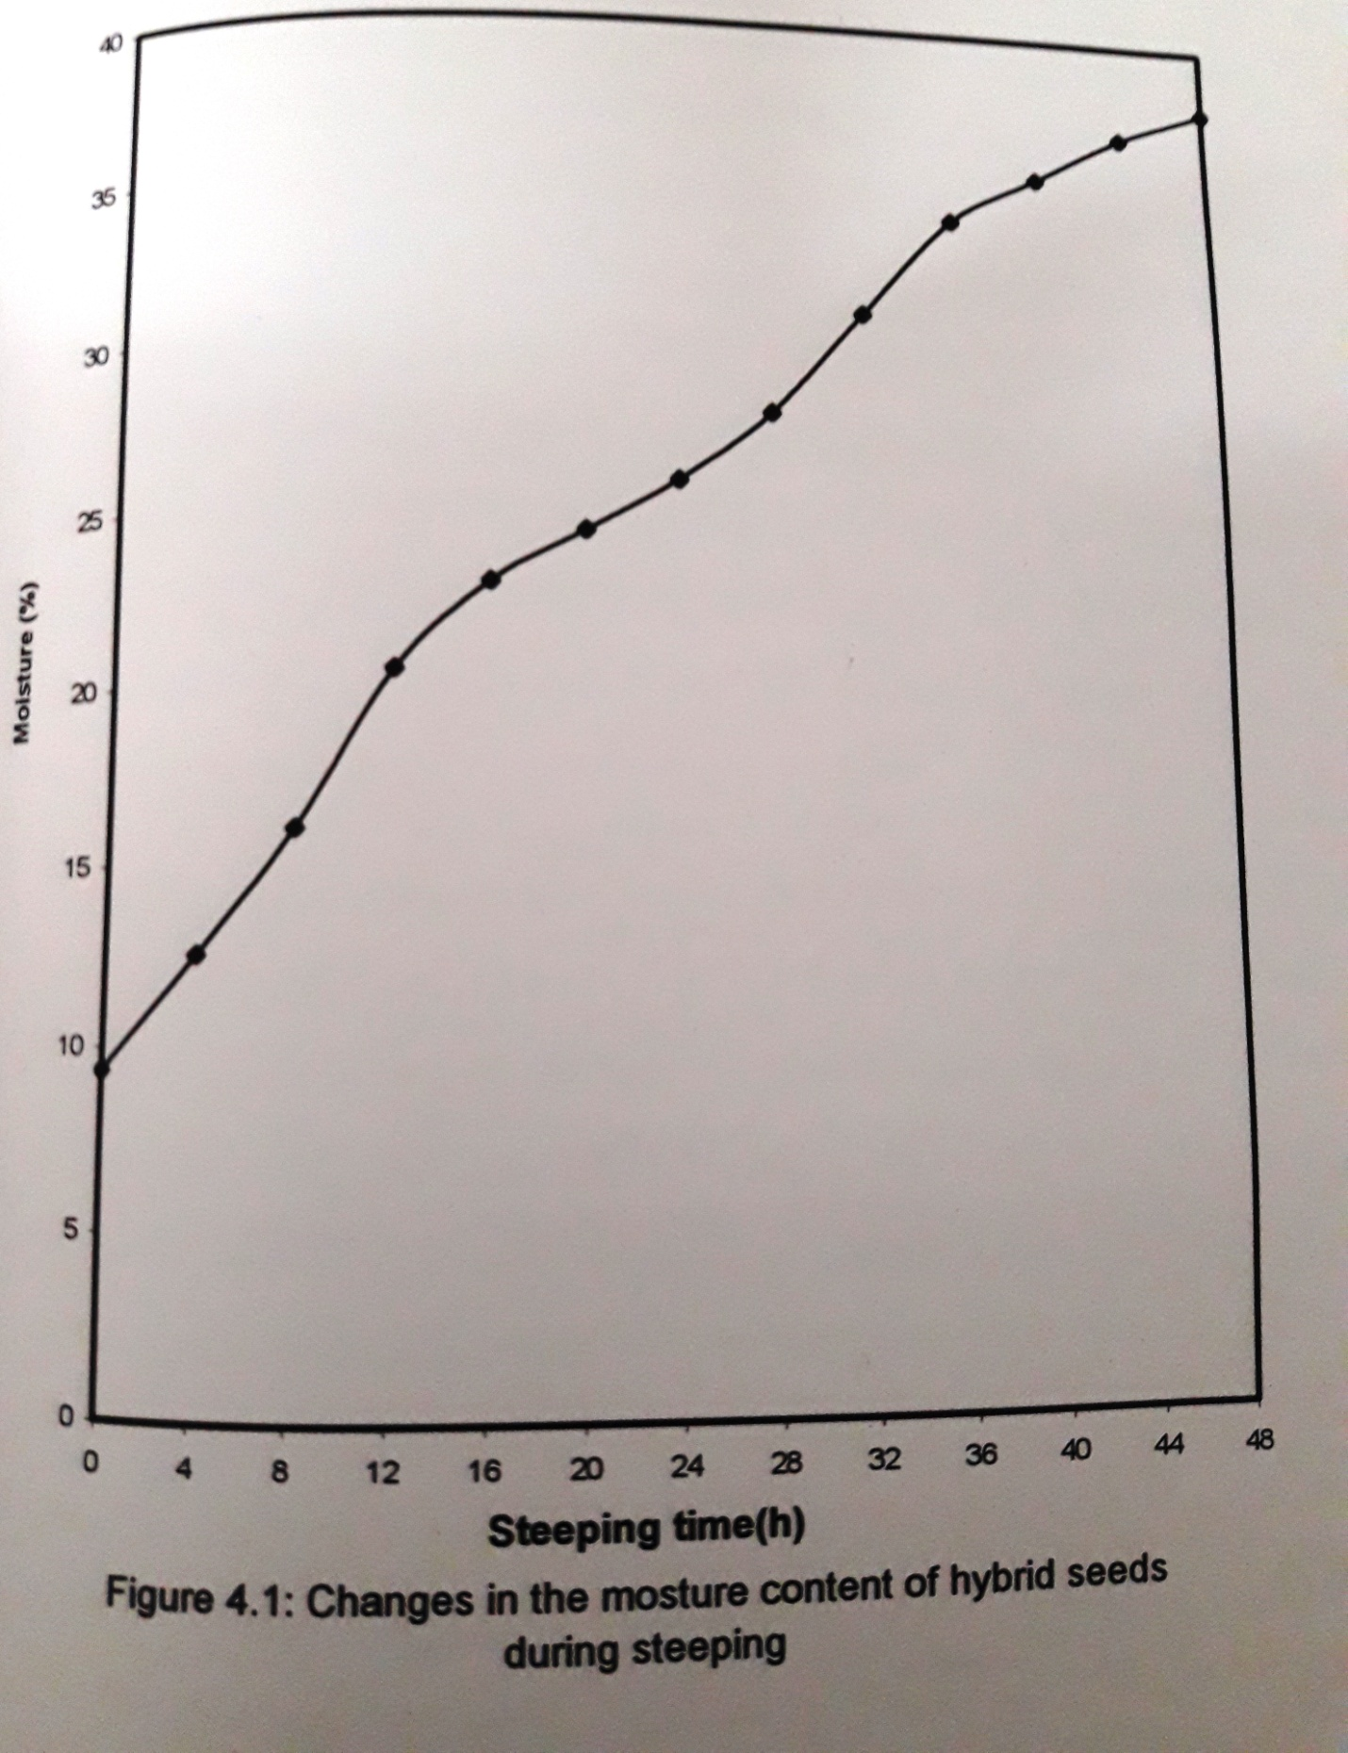

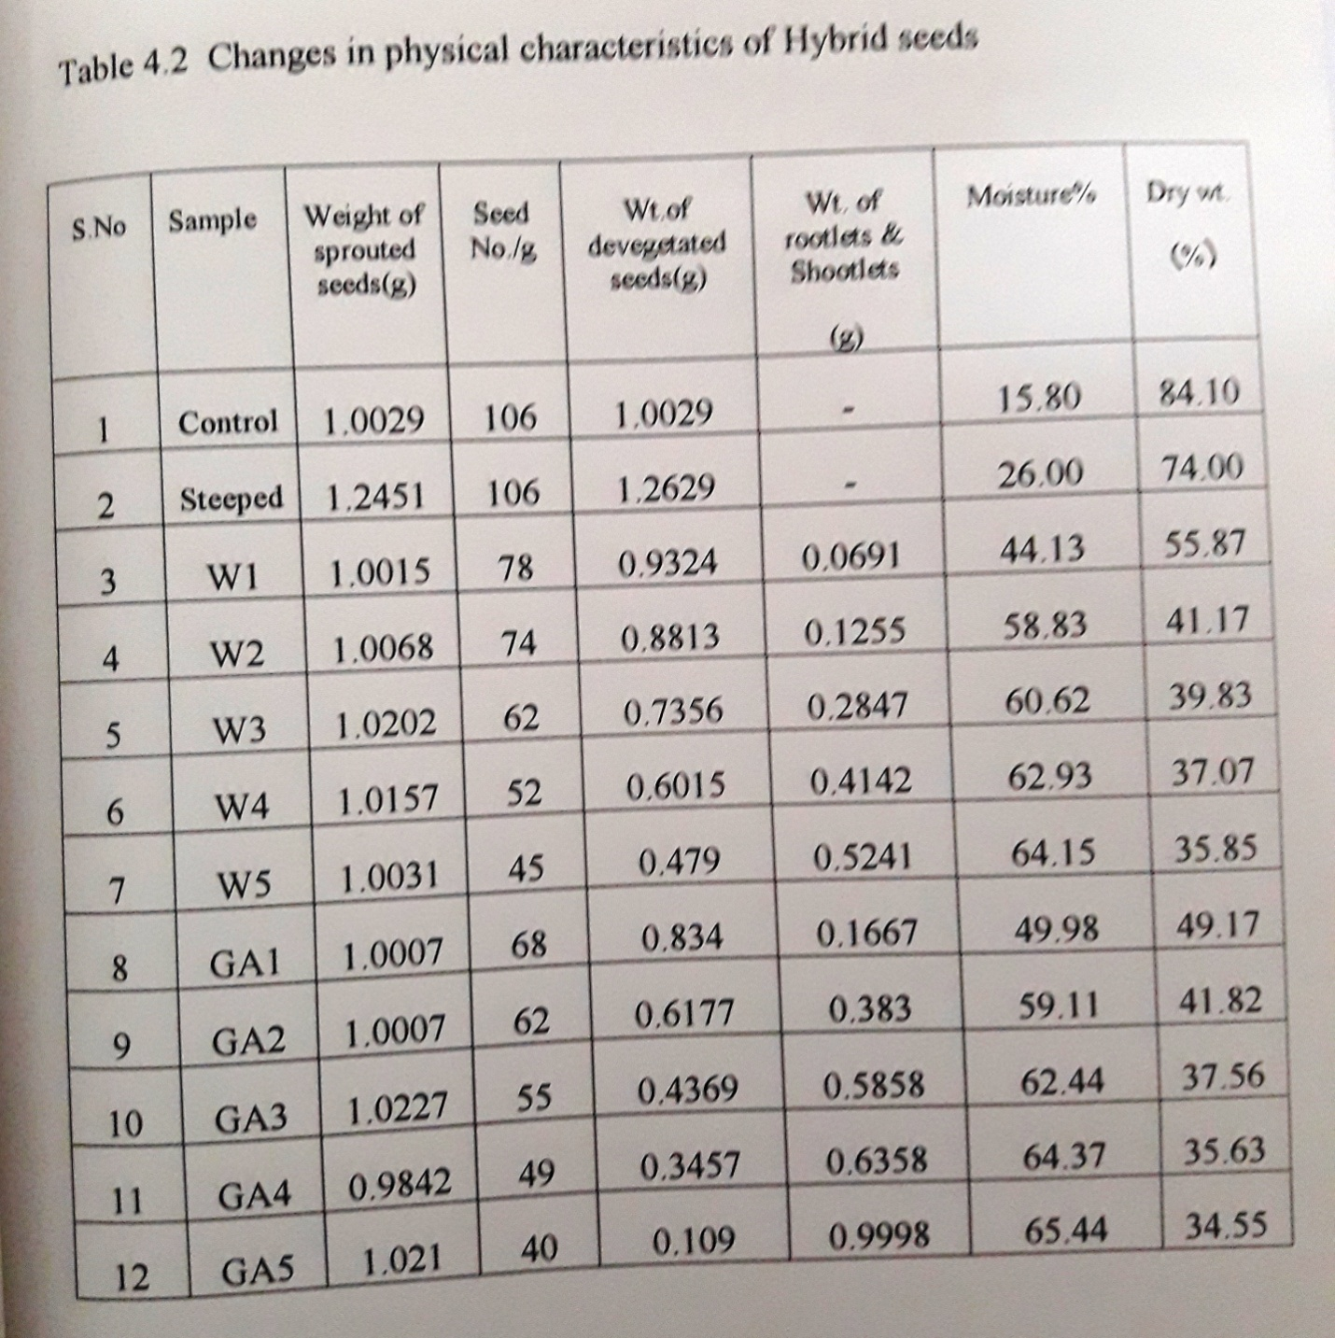

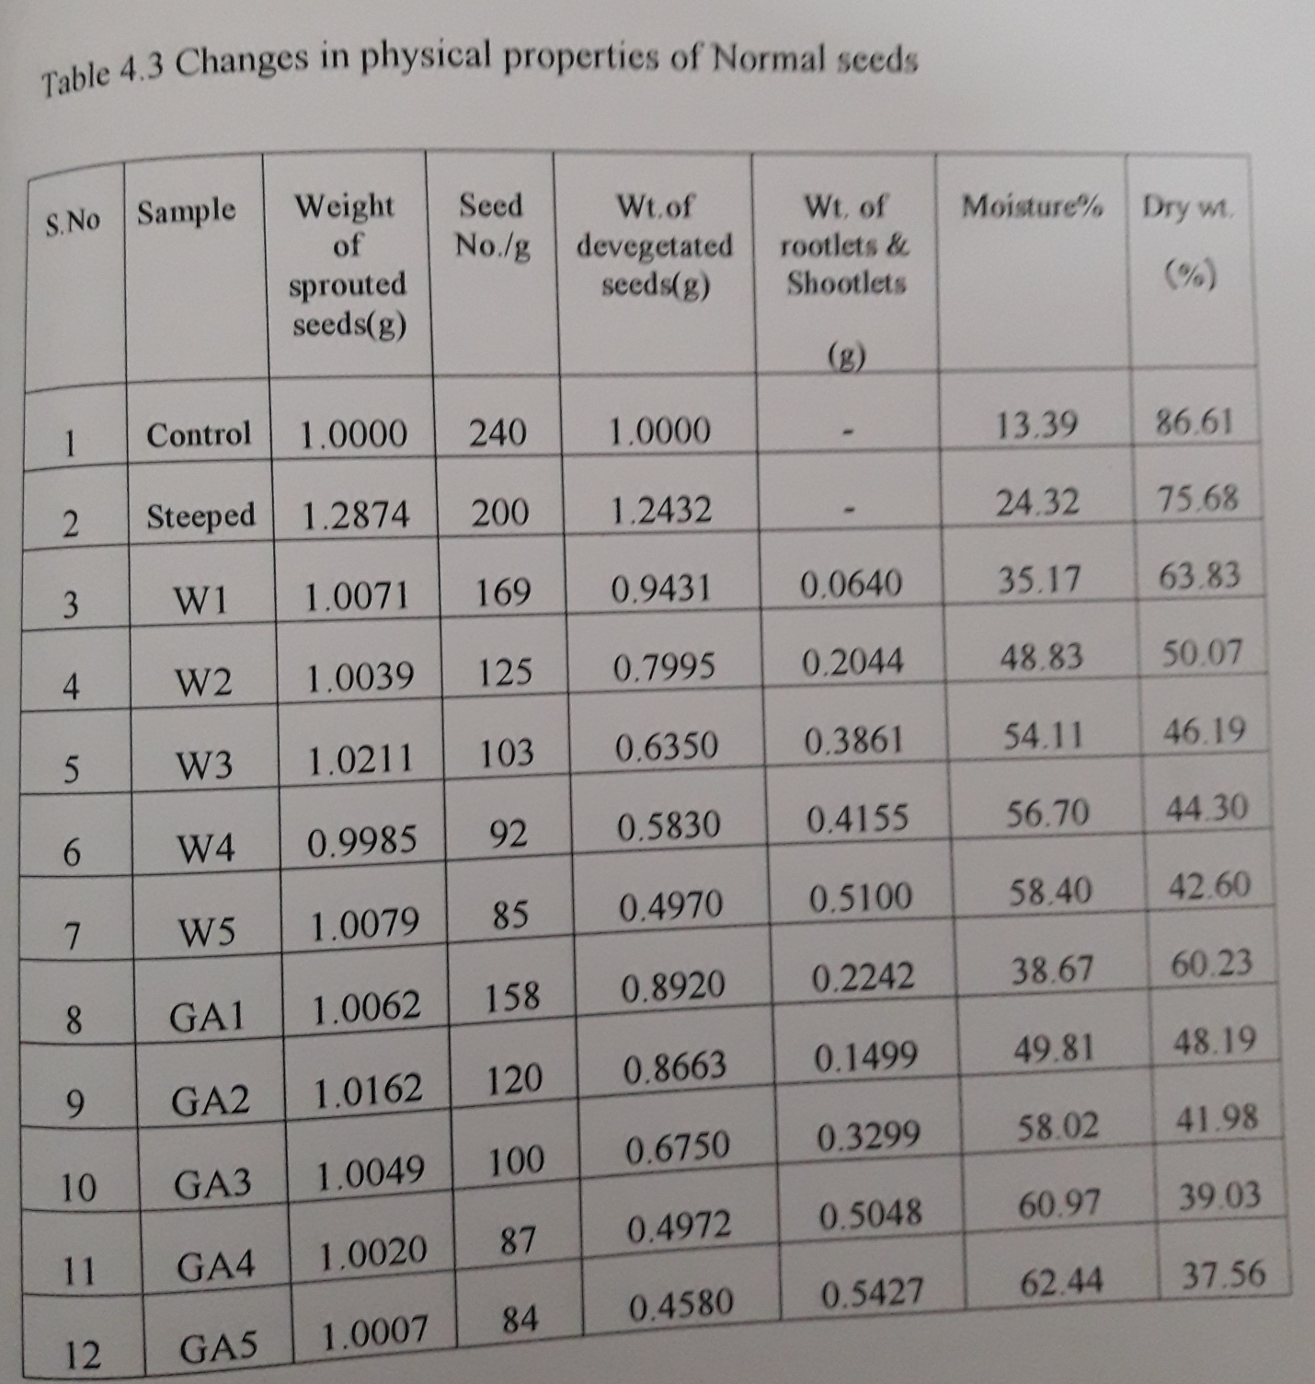

It should be noted that, in both hybrid seeds and normal seeds, the rootlets and shootlet weight is more in GA₃ treated when compared to the untreated samples. Gibberlic acid should be applied after steeping, as the pericarp is impermeable to the externally applied GA₃ ( Palmer, 1969). This plant hormone is reported to stimulate the aleurone layer of barley to release enzymes, which modify barley seeds reserve materials ( Yomo, 1958; Paleg, 1960). Hence the rate of seed germinations has increased and therefore an increase in rootlet and shootlet weight was noticed in case of the GA₃ treated samples. Figure 4.2 shows the stages of germination of hybrid seeds. The moisture content also increases with time. Both these results affect the numbers of seeds present per gram of sample as the rootlet and showed maximum growth in hybrid seeds when compared to normal seeds as it is evident from the figure 4.3, shootlet weight and moisture percentage were more in sprouted ones treaded with GA₃.
4.2.1.1 Changes in dry weight of the seeds
Dry weight of the seeds was also monitored. The initial dry weight of the seeds is observed to decrease with time. During steeping, a loss of nearly 12.01 and 12.61% was observed in the case of hybrid and normal seeds respectively. By the end of 5th day of germination a loss of 58.91 and 56.63% was observed in the case of hybrid and normal seeds treated with gibberlic acid (GA₃). In the untreated samples, it is 57.37 and 50.81 % respectively. The loss in dry matter in wheat was reported tot be 59% when germinated for 10 days at 30ºC (Nielsen et al, 1978). This decrease may be due to leaching of materials and oxidation f substances from the seeds during soaking and sprouting process.

4.2.3 Changes in the chemical composition of seeds
4.2.3.1 Changes in carbohydrate content
Table 4.4 and 4.5 reveal the changes in the starch and reducing sugar content of both the varieties under treated and untreated conditions of germination. During steeping process a loss in sugar content was observed, which later on increased with germination. The starch content steadily decreased with time. The hybrid seeds have high starch content than the normal variety i.e., 70% and 65% respectively. The reducing sugar content was 3.526% and 3.16% respectively. The decrease in starch content was more in GA₃ treated samples when compared to the untreated ones. The percentages of starch hydrolyzed in normal and hybrid varieties of treated and untreated samples are 45.84, 48.54 and 38.27, 33.91% respectively.

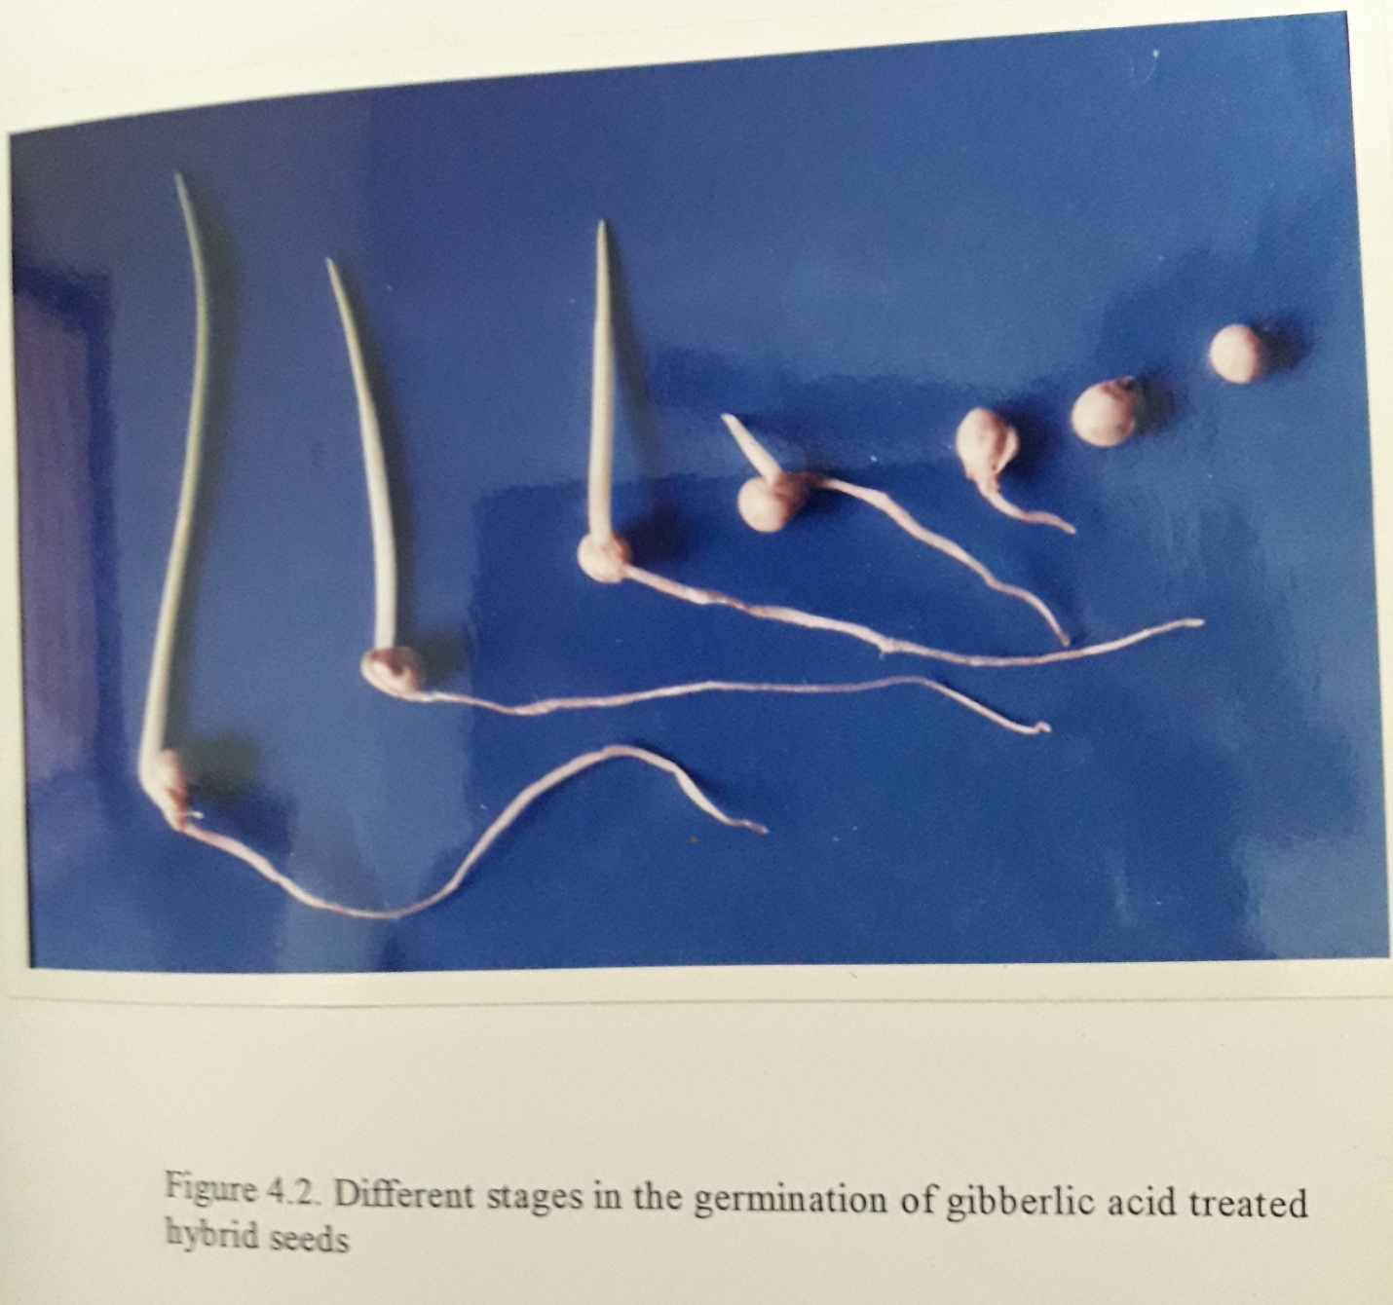

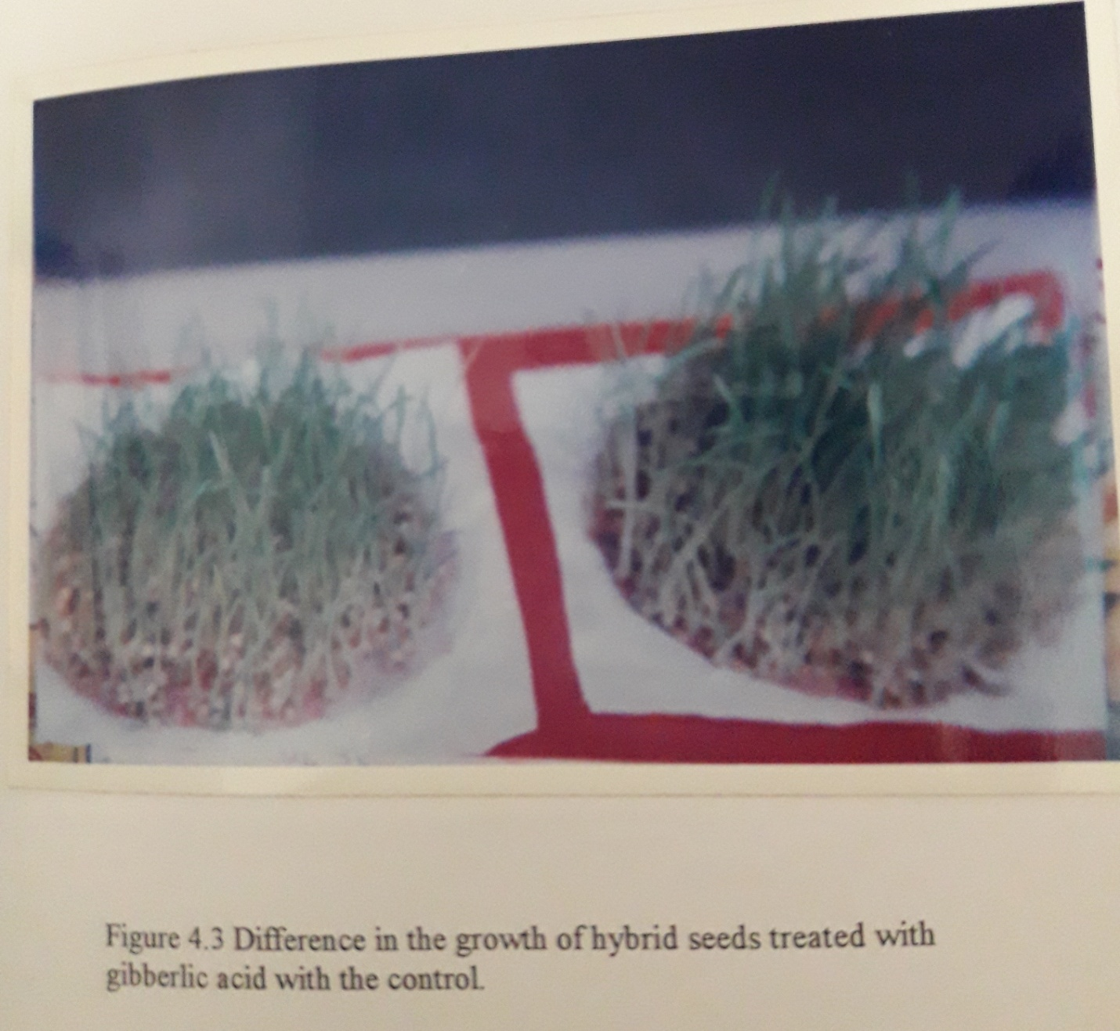

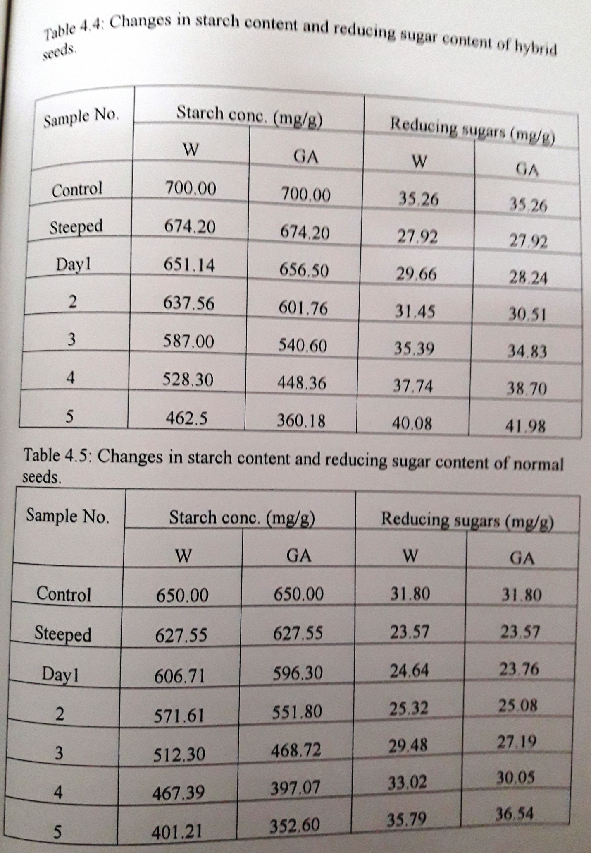
An initial decrease in the reducing sugar content may be due to their utilization by the growing embryo. The sugars were quickly metabolized during the first 24h of steeping. From then onwards, an increase in their concentration is observed. This may be due to rapid hydrolysis of starch, which releases reducing sugars, and the excess sugars were left unconsumed during germination. The increase in starch hydrolysis in gibberlic acid treated samples could be directly related to the increase in the synthesis of amylases by the seeds.
Similar results of changes in the starch and the reducing sugar content were reported by Andy R. Opuku et al (1983). Malleshi and Desikachar (1986), reported decrease in starch content to around 16% after 98h of germination. In corn, nearly 50% of the starch content was reported to have been hydrolyzed within 5 days of germination. A steady increase in reducing sugar content was also observed by Bartlett (1917).

4.2.3.2 Changes in amylase content
Samples collected after steeping and germination along with a control for both sets of the two varieties were collected. The sprouts are devegetated. The seeds were then used for the extraction of amylases as mentioned in the previous chapter.
The variations in the total amylase, alpha amylase and beta amylase activities of both the varieties were shown in figure 4.4 to 4.10. It may be noticed that there is an increase in their content for certain period of germination and later on decreased. In GA₃ treated seeds, the rate of amylases content obtained for hybrid variety and normal variety on the 3rd day are 301.4 and 250.18 maltose units per gram of malt (figure 4.4 and 4.6). The untreated samples showed 207.23 and 197.43 maltose units on the 4th day of germination respectively. The beta amylase synthesis was observed to be rapid during initial stages of germination, which decreased later during the 4th and 5th days of germination (figure 4.8 and 4.9). The optimum values of alpha amylases for GA₃ treated hybrid and normal seeds are 263.10 and 214.73 maltose units per gram of malt and those in the untreated seeds are 191.63 and 154.02 maltose units respectively (figure 4.5 and 4.7). The hybrid variety treated with GA₃ showed maximum amylases synthesis by 3rd day of germination.
Gibberlic acid is a plant hormone which when applied at very low concentrations of 1ppm is reported to cause induction for the expression of genes responsible for amylase synthesis. Similar results of induction were observed in barley by Palmer (1973) and Atand and
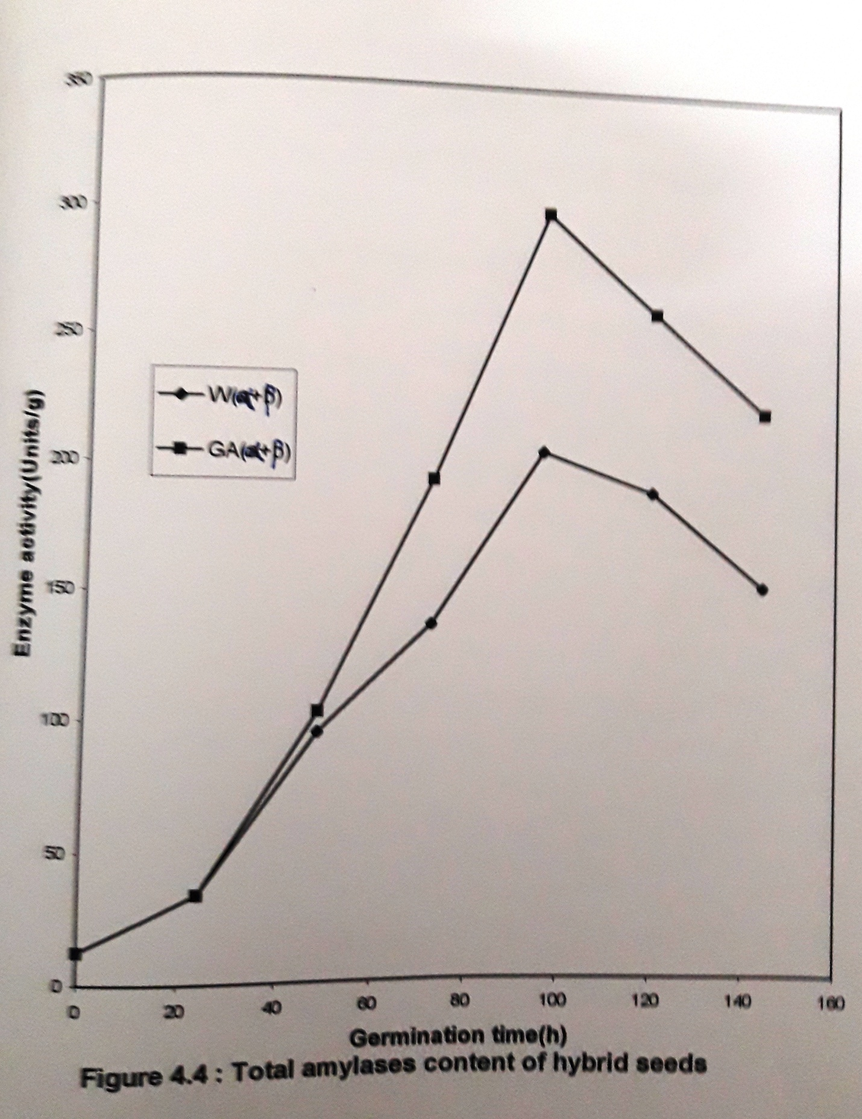
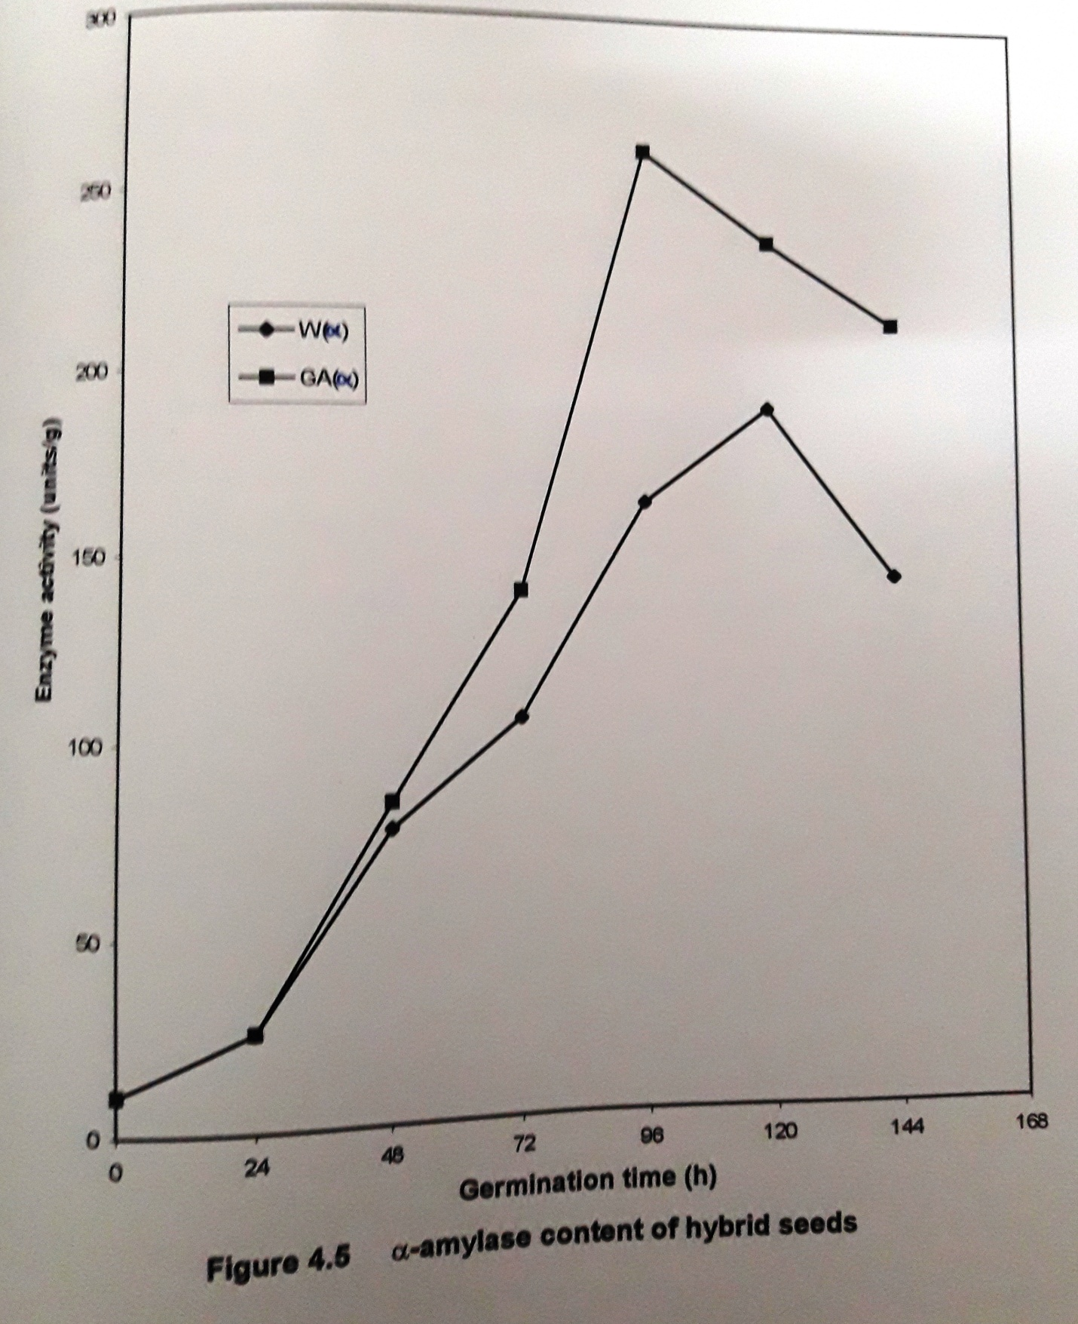

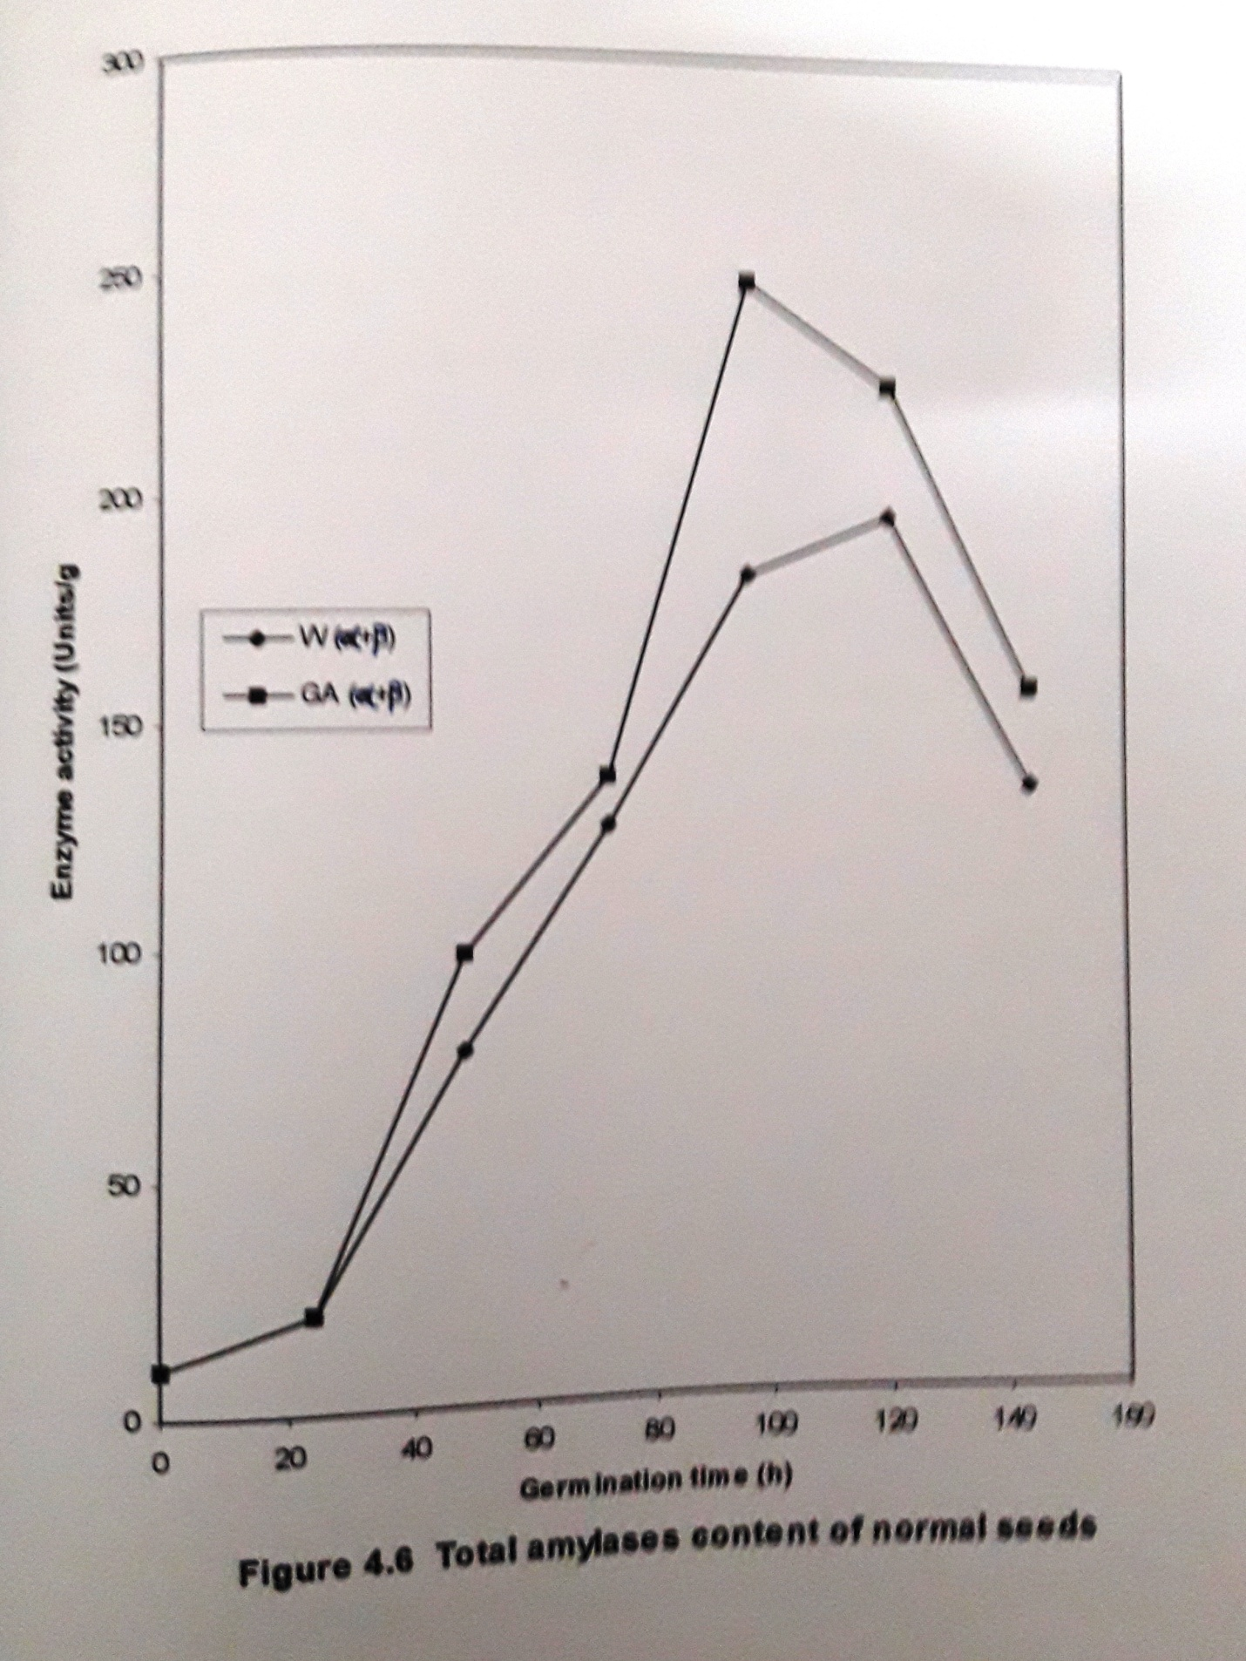

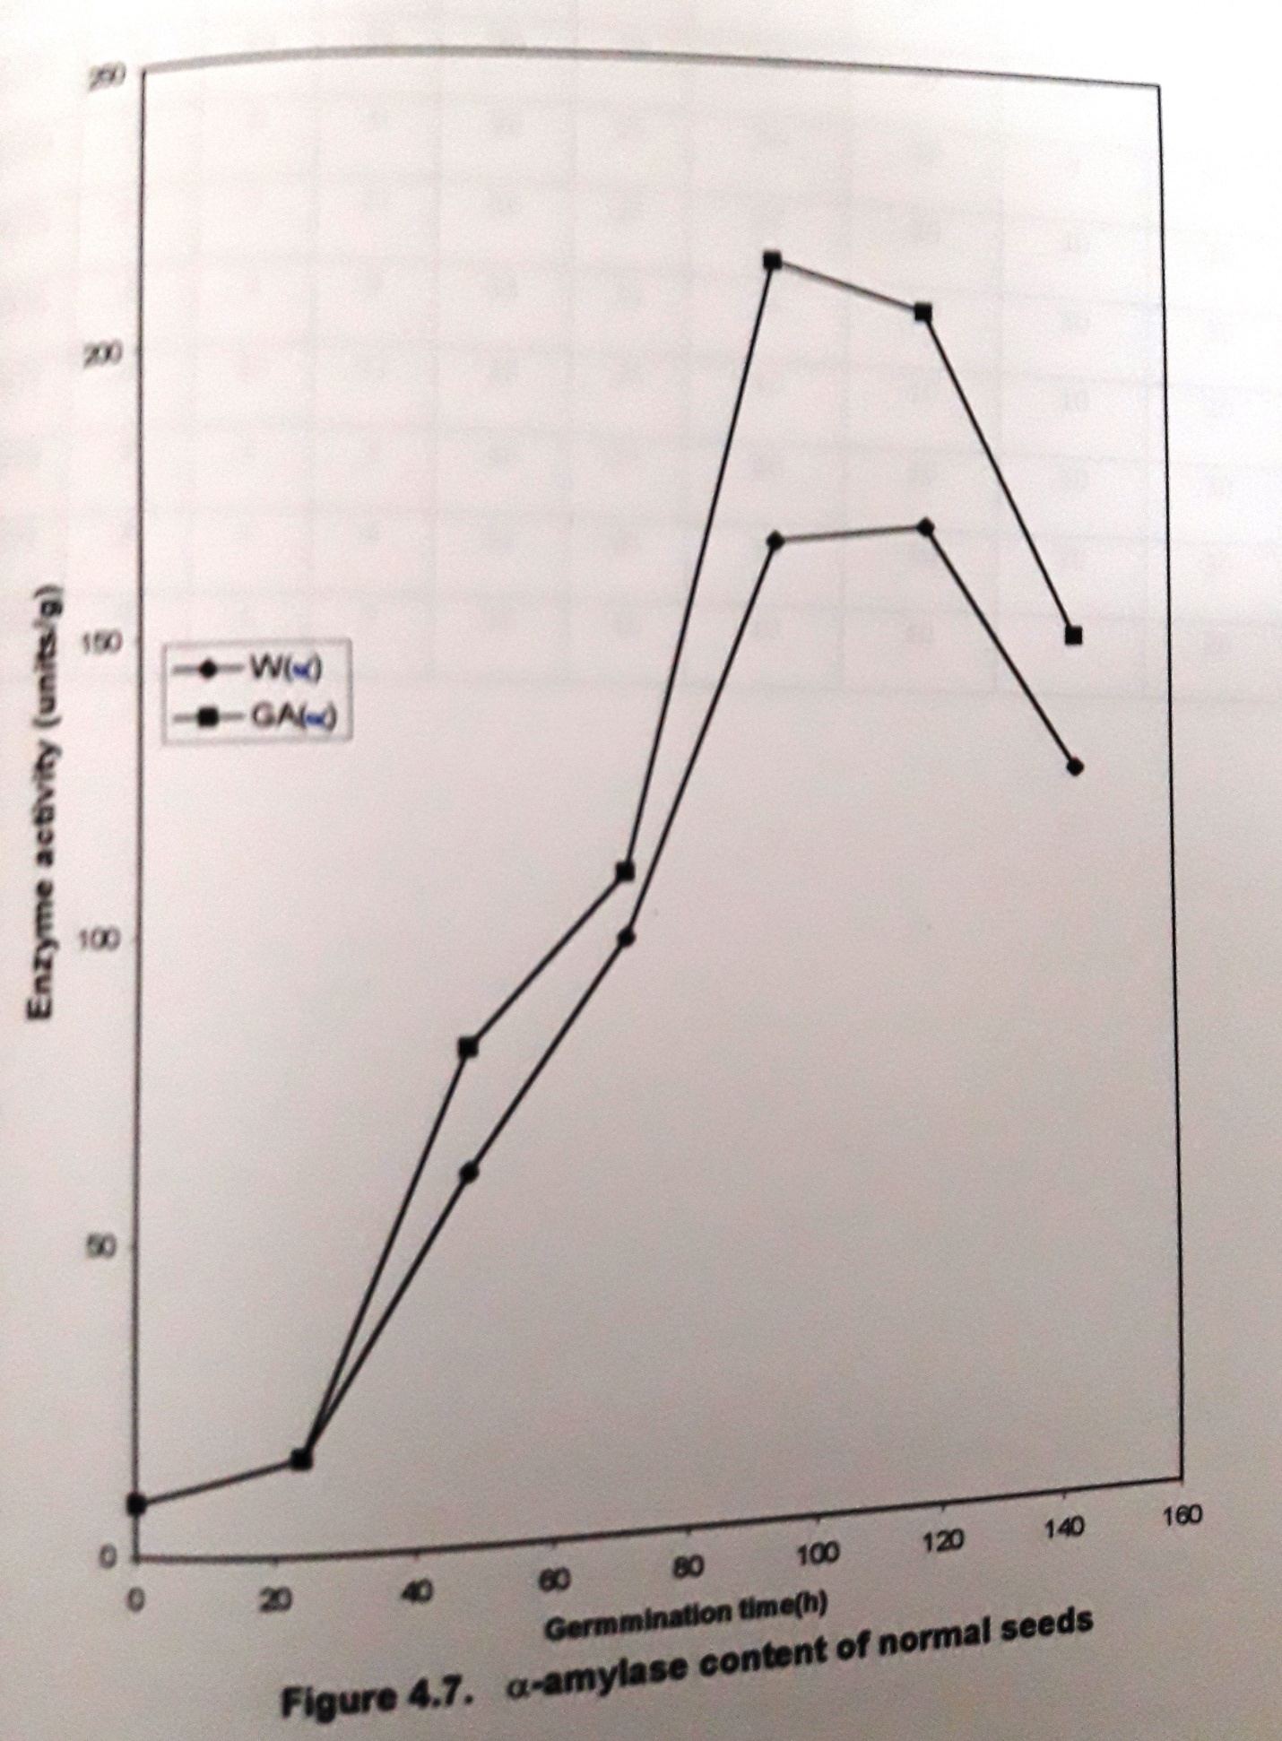

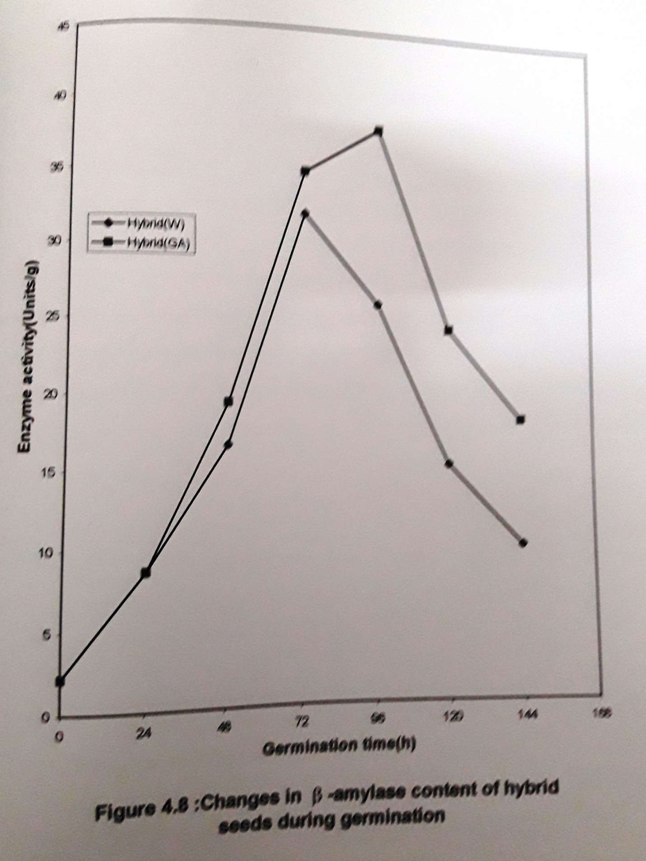

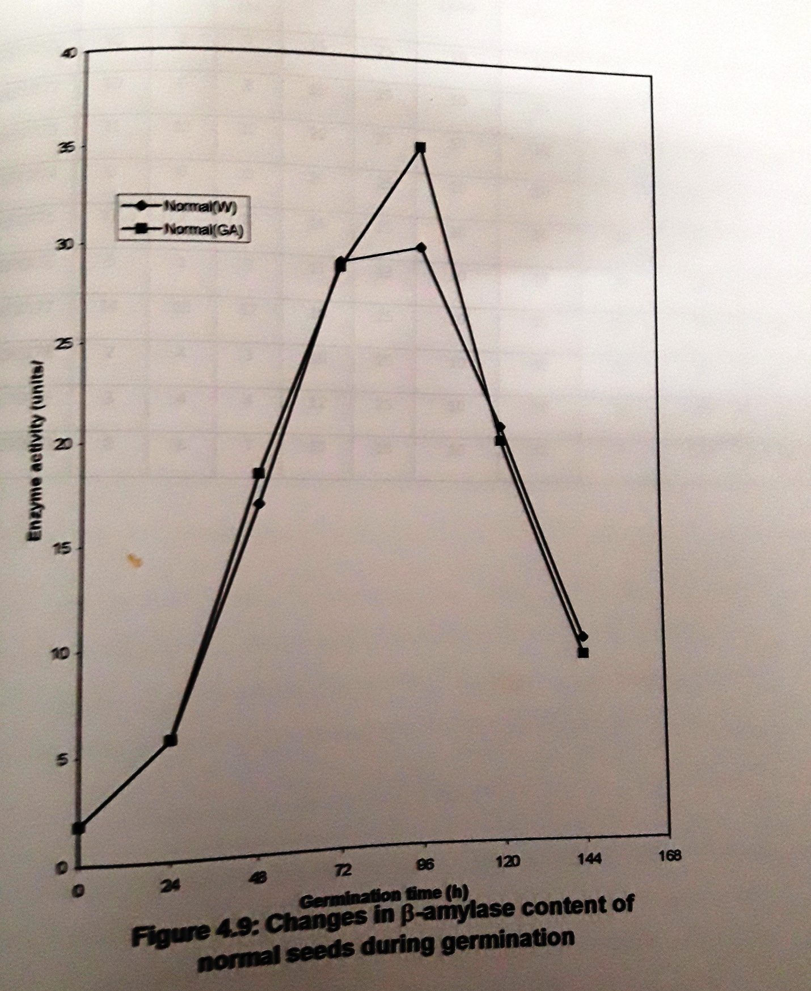

Miflin (1976). Alan Macey and Stowell (1961) also confirmed that external application of 1 to 3ppm gibberlic acid accelerated the rate of malt modification. Malleshi and Desikachar (1986) reported a production of 170 maltose units of amylases by 48h of germination, which has decreased by the end of 3rd day of germination.
4.2.3.3 Changes in protein content
The changes in protein content of both the varieties are listed in table 4.6 and 4.7. During the steeping process a considerable decrease in the protein content is observed. During germination it increased during the first 2 days, which later on decreased by 5th day of germination.
The hybrid seeds contain more amount of protein when compared to the normal variety. The decrease in the protein content during steeping can be attributed to the insitu utilization of the soluble proteins by the germinating embryo during the early germination period when there is little proteolytic activity developed in the seeds (Malleshi, 1984). A steady decrease in protein content of pearl millets was reported for a period of 46h by Malleshi nd Desikachar (1986).
An optimal protein concentration of 12.28g/ 100g of devegetated malt was observed in the case of hybrid seeds when treated with GA₃ on the first day of germination. The increase in protein content may also be due to the rapid decrease in starch content of the seeds during germination.

4.2.3.4 Changes in proteolytic acitivity
Table 4.6 and 4.7 represents the changes in proteolytic activity of both the varieties. A significant increase in the proteolytic activity was observed upto 3rd day of germination of the seeds, which later on decreased. A similar trend was observed in the specific activity of the proteases also.
By the end of 3rd day, an increase in the proteases activity was observed by 3.1 and 3.9 fold at the end of 3rd day in untreated samples of hybrid and normal seeds. In GA₃ treated samples, the increase in proteases is 3.7 and 4.5 fold when compared to the control. The optimum specific activities for untreated normal and hybrid seeds were 105.61 and 119.87 and that in GA₃ treated are 118.43 and 134.68. the units for specific activity are mg of casein hydrolyzed per hour per mg of protein. The hybrid seeds treated with GA₃ showed high proteolytic activities when compared to other samples.
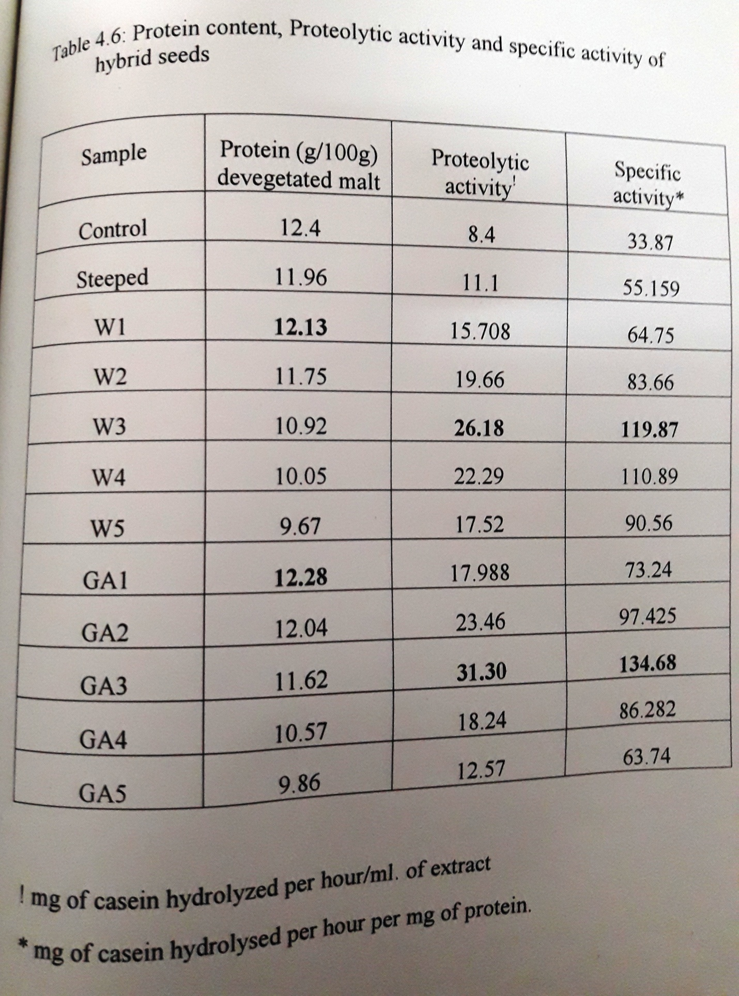

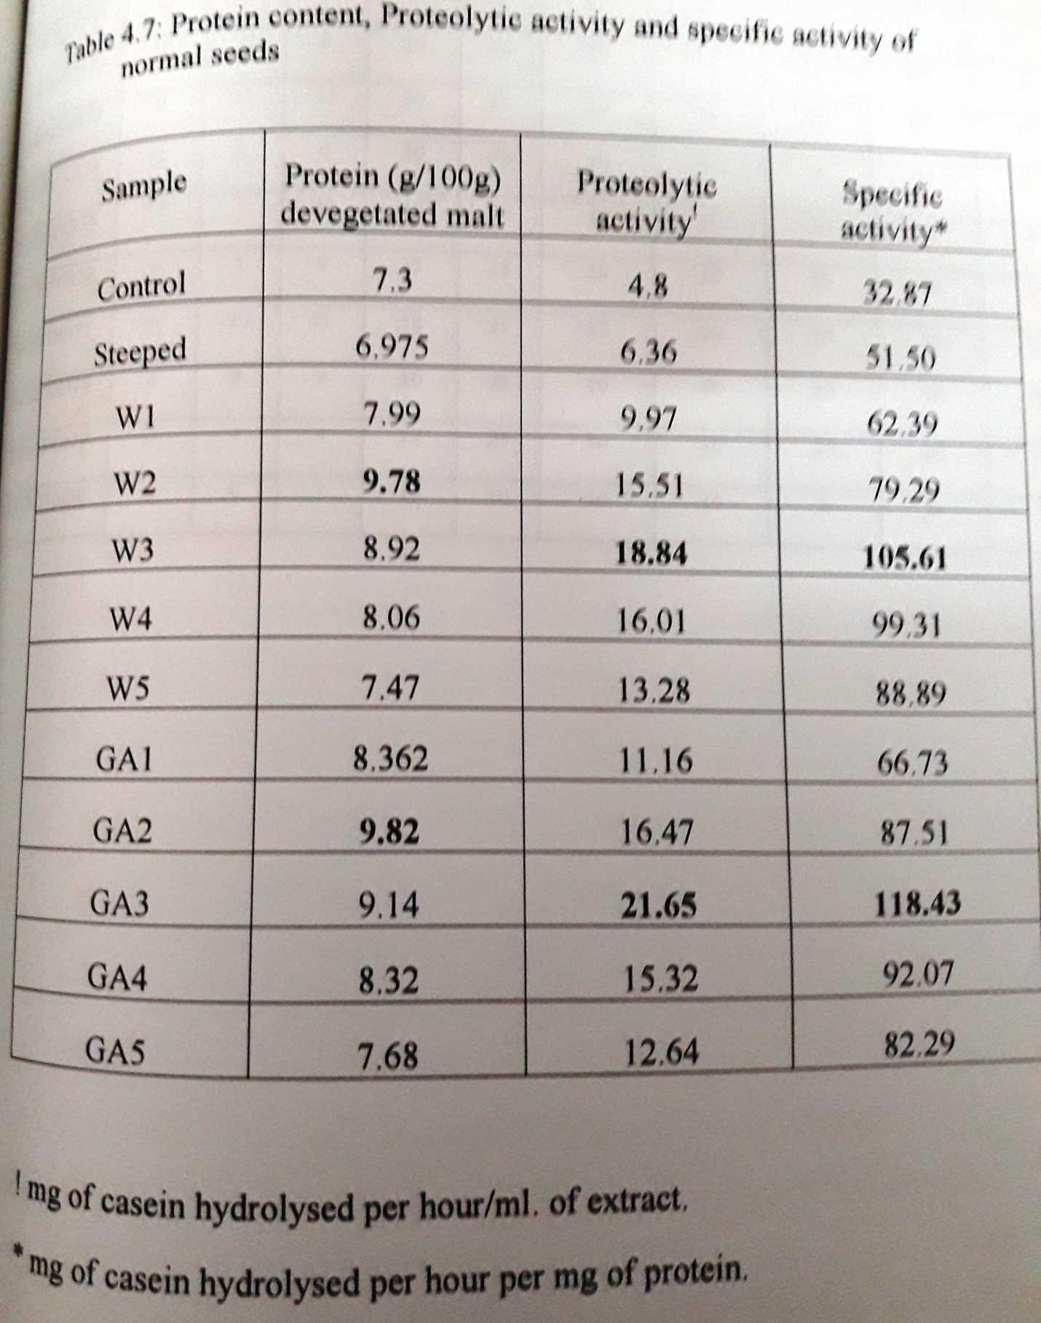

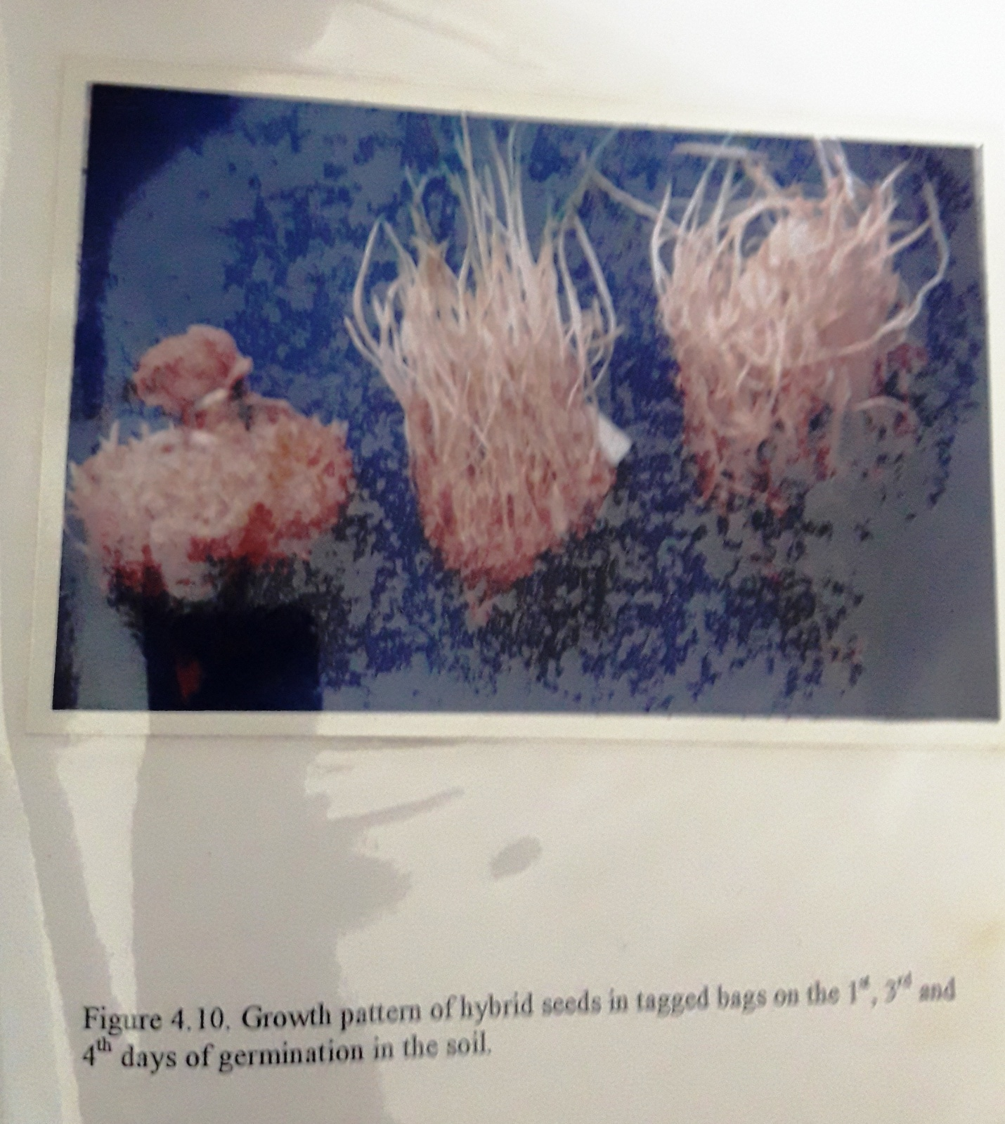

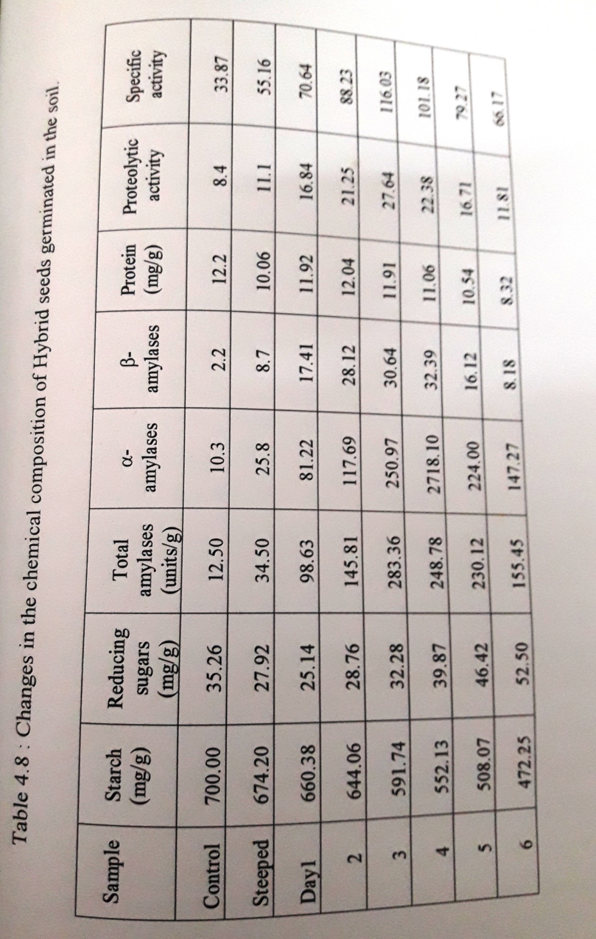

4.3 Germination fo hybrid seeds by traditional method
From the above observations, hybrid seeds were found to yield good malt. Hence these seeds were selected to study the changes in the above studied parameters when grown in the soil. At industrial level to sprout large quantities of grains rotating jars are used (Miller, 1978). At domestic level any containers viz., plates, bowls, pans, trays can be used. In villages to get sprouts in short time, the seeds after soaking are drained completely to remove water, tied in a wet cloth and are kept in a warm place. Usually they keep the seed bags in the soil. This method was tried by keeping the tagged seed bags at about 1 foot below the soil surface.
Six separate bags were placed in the selected place at about 1 foot distance from each other. One bag was removed on each day for the analysis of the chemical composition of the germinated seeds. Figure 4.10 shows the growth pattern of hybrid seeds in tied bags on the 1st, 3rd and 4th days of germination in the soil.
The results were shown in table 4.8. by 6th day 32.53 % starch was hydrolyzed and the reducing sugar content has increased from 35.26 to 52.50 mg/g of malt. The total amylases were more on 3rd day (283.36 maltose units/g of malt), which was less when compared to GA₃, treated samples. The proteolytic activity steadily increased till 3rd day and the protein content varied during germination. The maximum specific activity for proteases was observed on 3rd day, i.e., 116.03 mg casein hydrolyzed/h/mg of protein. The comparative amylolytic and proteolytic activities during the germination of hybrid seeds by the three methods, i.e., GA₃ treated, untreated (W) and the samples grown in soil (soil) were shown in figure 4.8 and 4.9. It may be noted that GA₃ treated samples of hybrid seeds were rich in amylases as well as proteases when compared to the rest of the samples.

4.4 Selection of malt source
Based on the above studies, hybrid seeds were selected as source for malt and gibberlic acid treatment was selected as germination method as it resulted in high levels of amylases and proteases. The composition of malt derived from hybrid seeds on 3rd day of germination as shown in table 4.9.

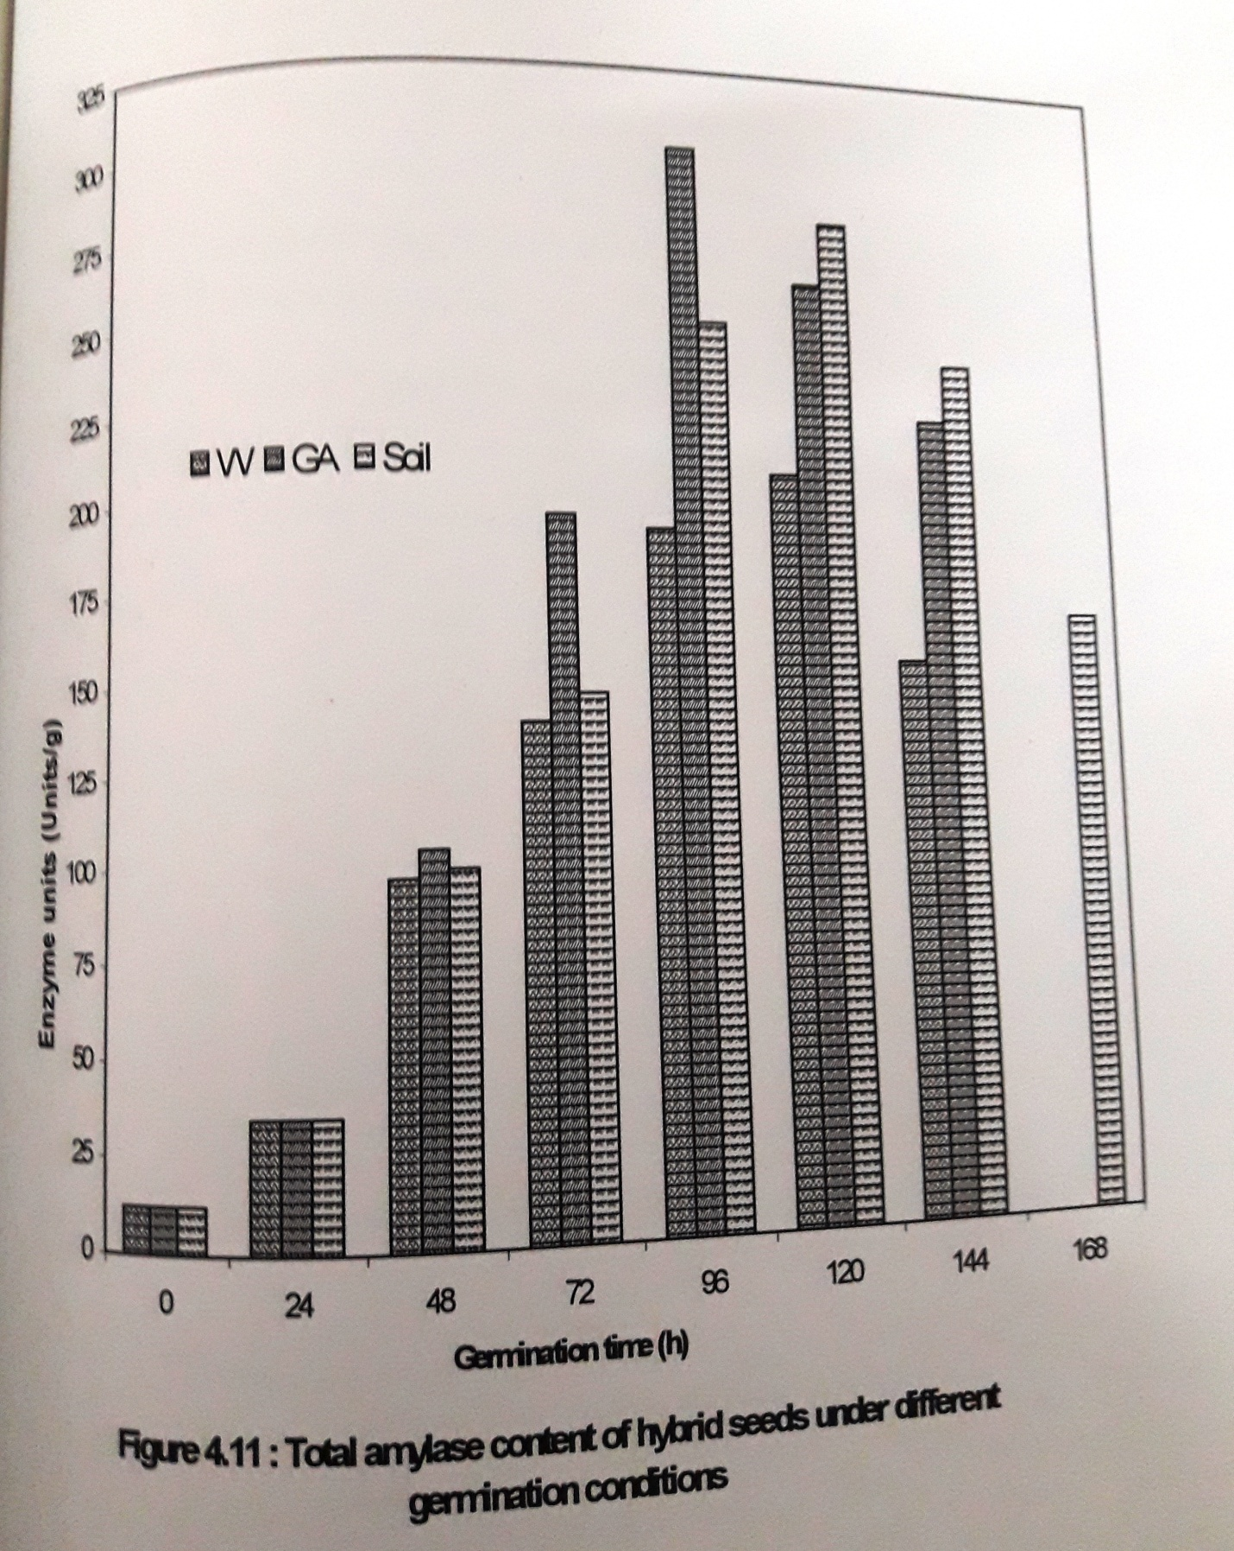

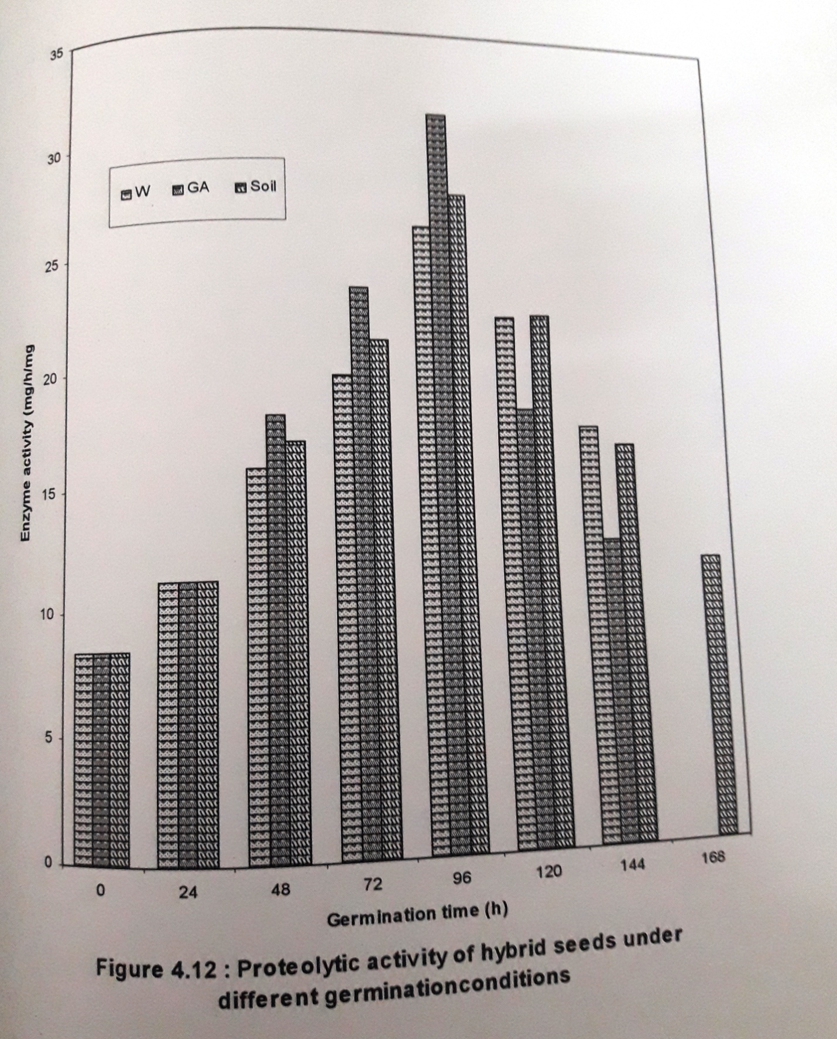

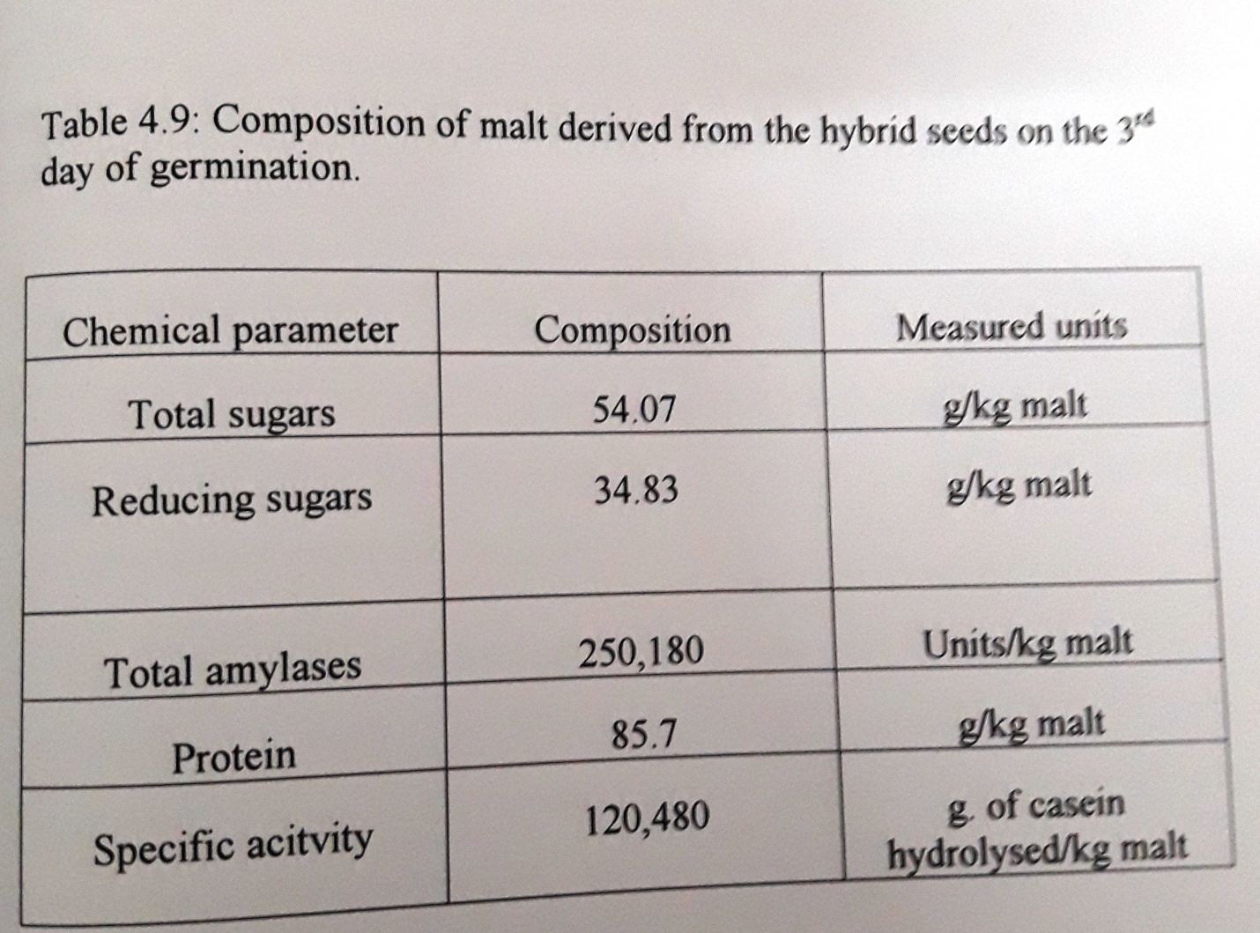

4.5 Characterization of pearl millet α- amylases
The factors, which can enhance the performance of pearl millet alpha amylases were studied. The physical parameters such as molarity of the buffer in which the amylases are extracted, its pH and the chemical factors such as CaCl₂ and metal activators, which can be incorporated during mashing were identified.

4.5.1 Effect of acetate buffer molarity
The amylases from the 3rd day devegetated seeds were extracted in cold acetate buffer. The molarities of the buffer selected for the study were varied in the range 0.005 to 0.05M. The extract was centrifuged and the supernatant was subjected to denaturation of beta amylases. This was centrifuged again and the supernatant was used as the source for alpha amylase. The starch solutions were prepared in the mentioned buffer solutions and used to study the effect on alpha amylases at the individual molarities.
Optimum enzyme activity was observed when 0.2M buffer solution was sued (figure 4.13). Further increase in buffer molarity resulted in a slight decrease in activity at 0.02M buffer. A maximum reducing sugars concentration of 3.91 mg was released at this molarity whereas 3.645mg were released when 1% starch solution in water was used as the substrate in the control.

4.5.2 Effect of pH
The pH of the buffer was varied between pH 3.0 and 6.5. The optimal pH for alpha amylase activity was 5.0. The results were shown in figure 4.14. There was a rapid drop in enzyme activity above the optimal pH. Reed and Thorn (1971), reported that alpha amylase derived from wheat shows maximum activity at pH 5.0. They reported that there was a steady increase in activity with pH upto pH 5.0 and later a decrease in activity was observed with further increase in pH. In the present study the decrease in pH below 4.0 resulted in a rapid drop in enzyme activity and above pH 5.0 decrease in activity was slow.
4.5.4 Effect of Calcium Chloride
Calcium ions increase the stability f alpha amylases when exposed to high temperatures. Different concentrations of CaCl₂ were added to the acetate buffer in the range 1 to 5 mM. The enzyme activity increased till 3mM CaCl₂ concentration and further increase did not show significant effect on the enzyme activity (figure 4.15). From the results, it may be concluded that
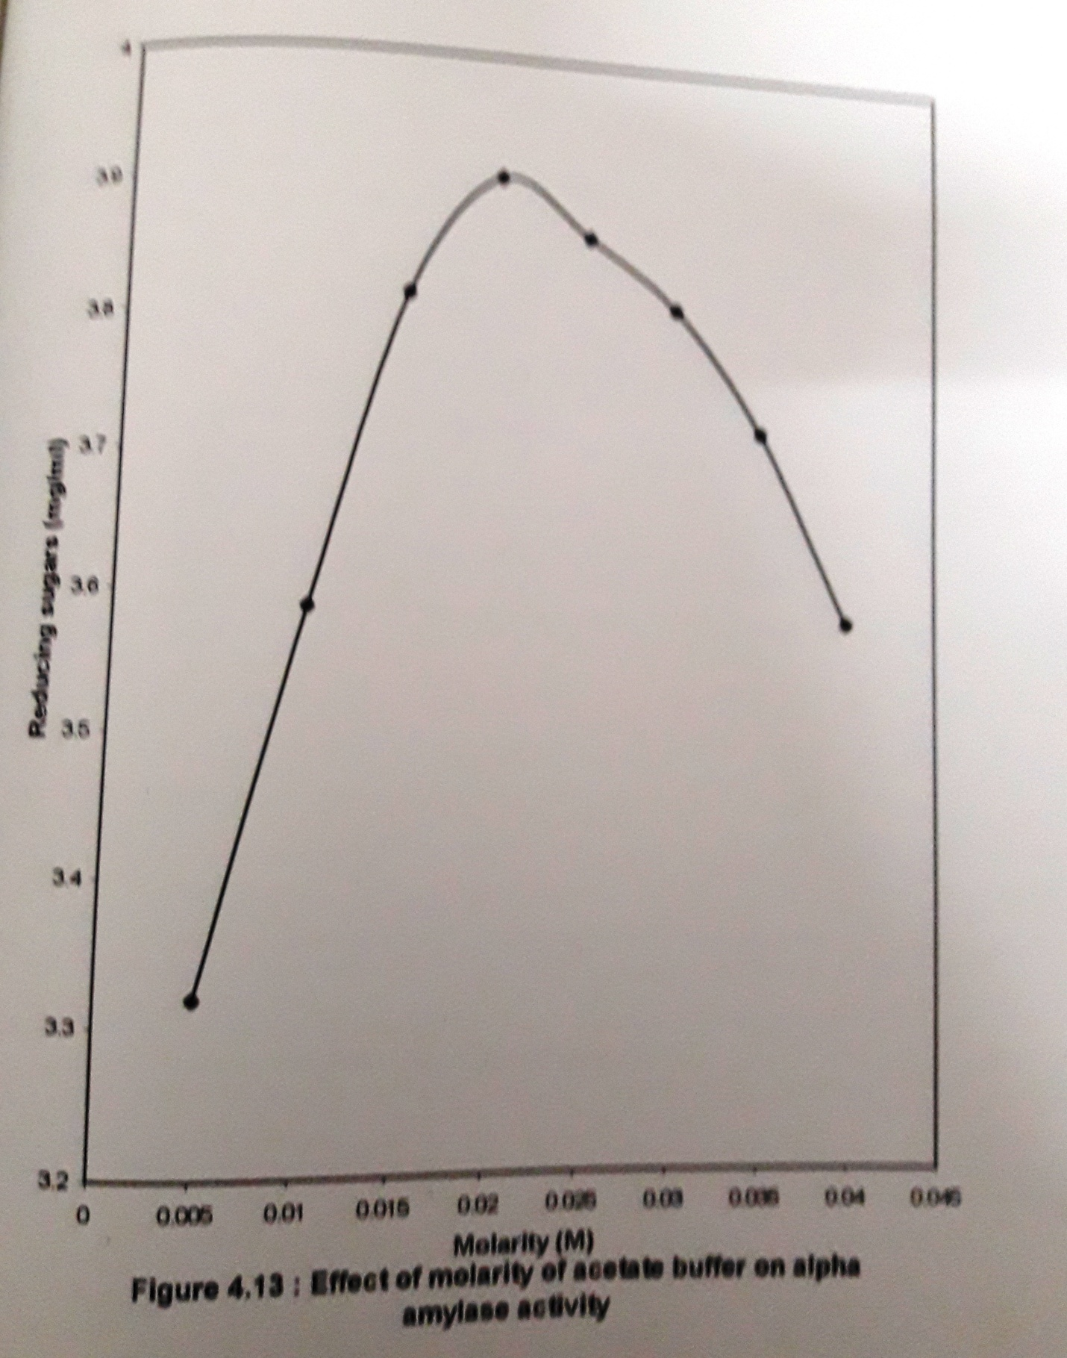

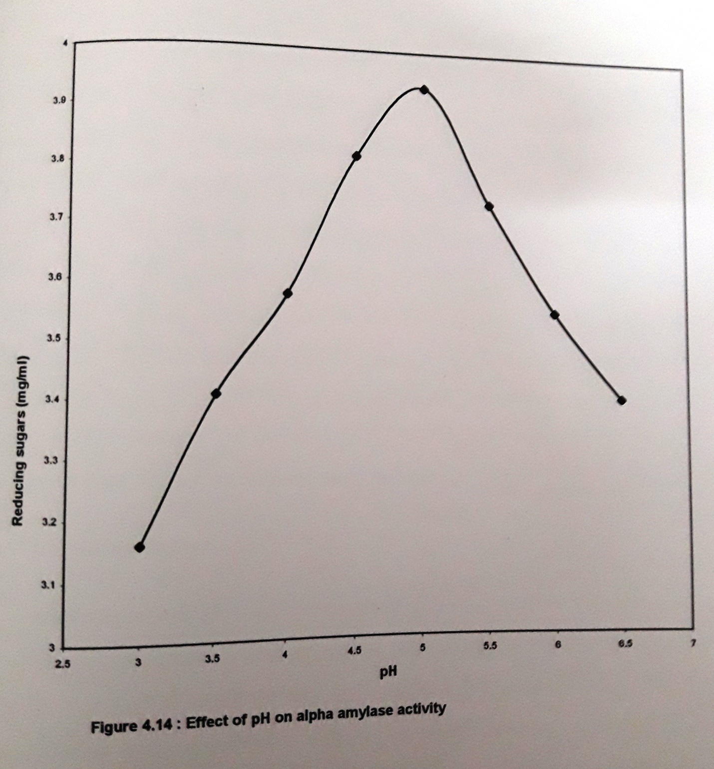

3mM CaCl₂ concentration offered maximum stability to the amylases. Kneen et al (1943b), observed that calcium ions increase the thermostability of wheat beta amylases as well as that of barley beta amylases. It increases the stability of alpha amylases of both the cereals.

4.5.5 Effect of metal activators
To identify the metal salts, which enhance the alpha amylase activity, the salts listed in the previous chapter were used. The effect of these metal ions on alpha amylase activity was shown in figure 4.16 to 4.18. Among the activators used for study FeSO₄ and KCl were found to be very good activators. FeSO₄ was not selected because even a slight increase in its concentration at ppm levels will show a deleterious effect on the enzymes in mashing since it combines with the proteins and precipitates them (Donald W. Ohlemer and Samuel A. Matz., 1970). Hence KCl was selected as the metal to be incorporated during mashing andit showed maximum activity at concentration of 0.003%. The chloride ions at levels of 20 to 60 mg/l are known to mellow and sweeten or soften the beer.

4.6 Mashing studies
Mashing is a highly skilled process and seasonal differences in the raw materials bring about changes in the malt. Hence care should be taken in the preparation of malt so that maximum sugars can be extracted by holding the malt to the selected starch (adjunct) source. The important variables influencing mashing are the substrate concentrate, percentage of malt and temperature. In the present study, the effect of stabilizer, activator and penicillin G was also investigated.
4.6.1 Effect of particle size on mashing
The effect of particle size of the pearl millet flour on mashing was observed. The milled flour was subjected to sieving through a set of sieves to obtain particles of different mesh sizes. The samples were labeled based on the sieve number, through which they pass, ie., -50 +70, -70 +100, -100 +150, -150 +200, -200 +250, -250 +300 and -300 British standard sieves.
To 10% of the flour of each mesh size, 2.5% malt was added and the mixture was subjected to mashing at 60ºC for 3h. The final reducing sugars concentrations were plotted in figure 4.19. It is a known fact that as the particle size decreases, more surface area will be available for the enzyme to act and hence an increase in reducing sugar concentration is

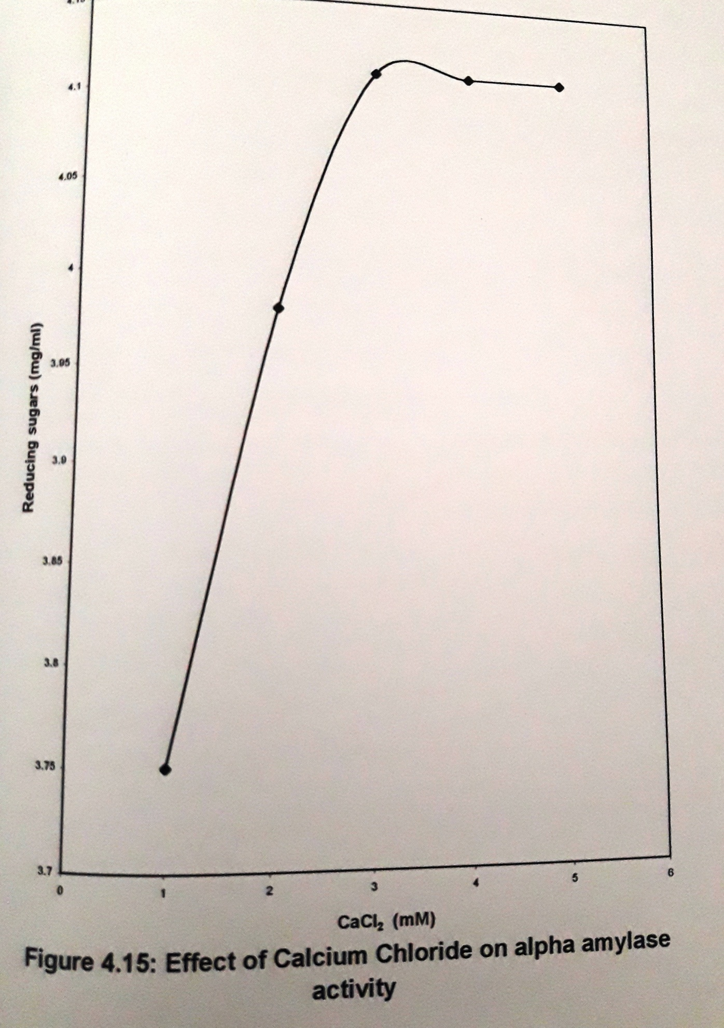
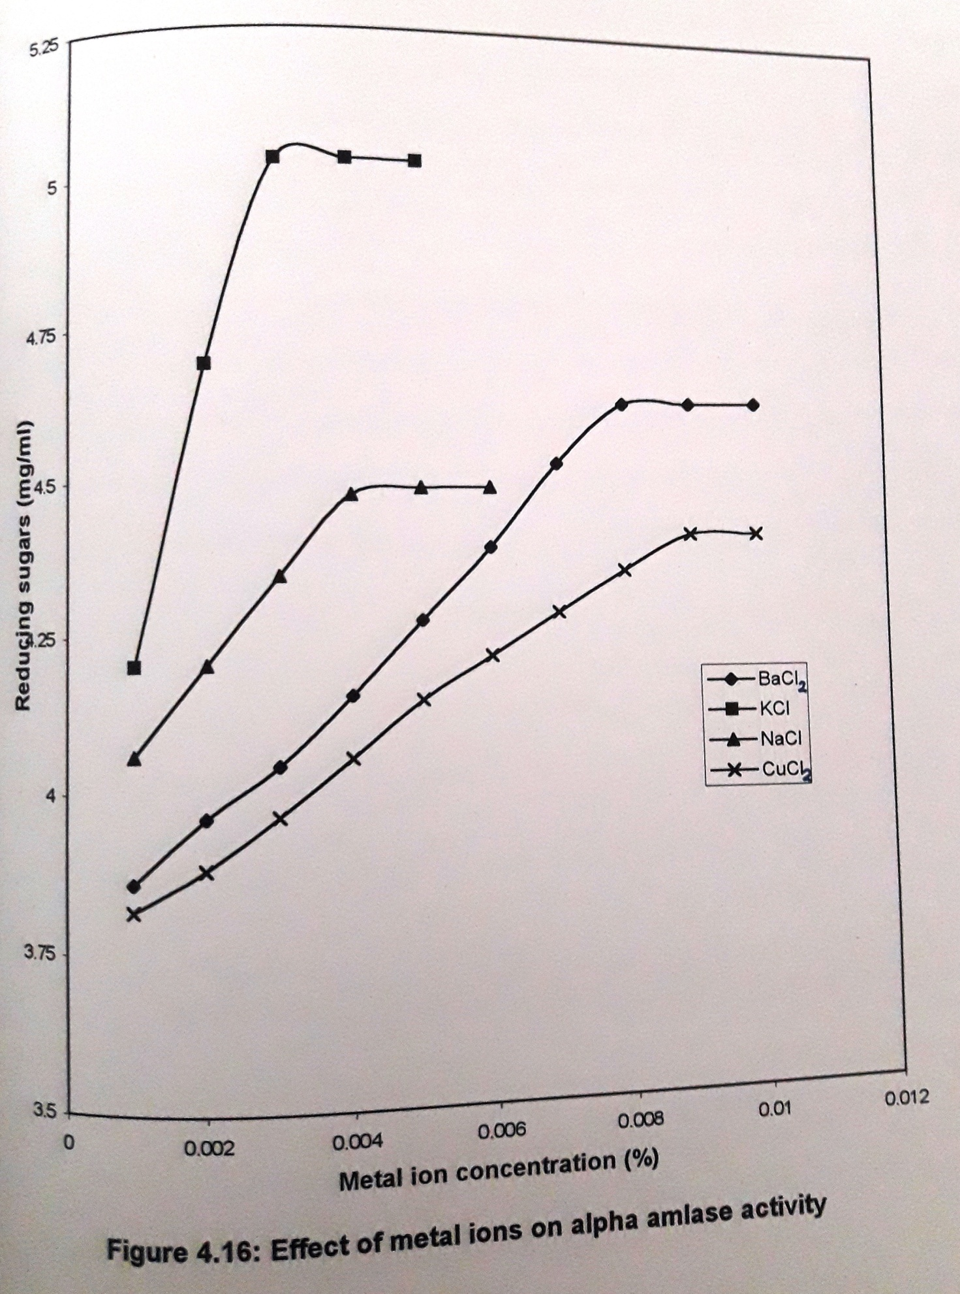
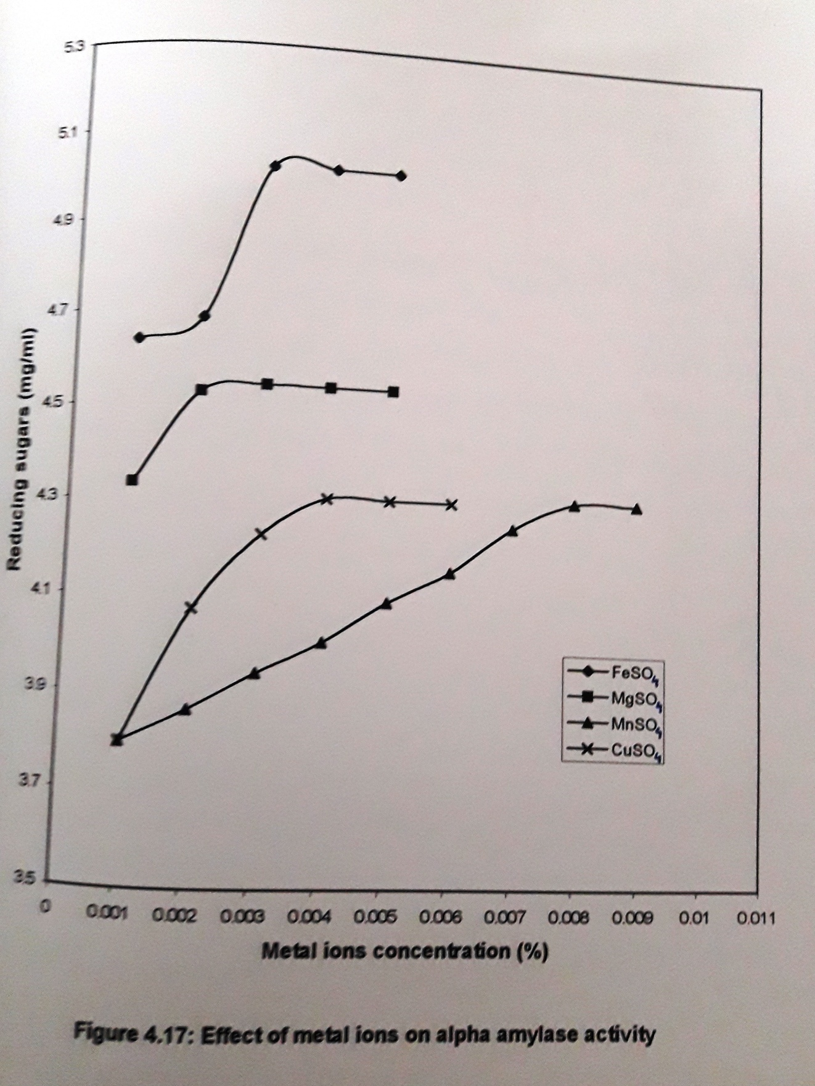
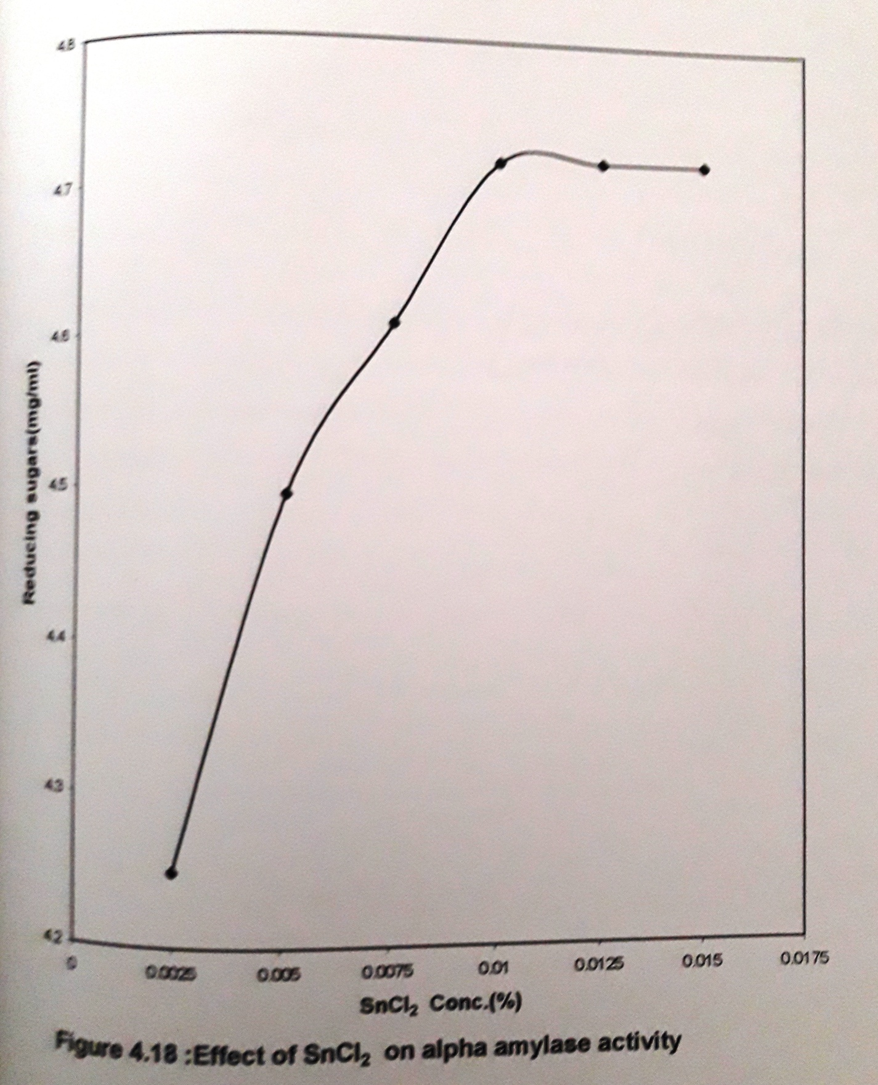
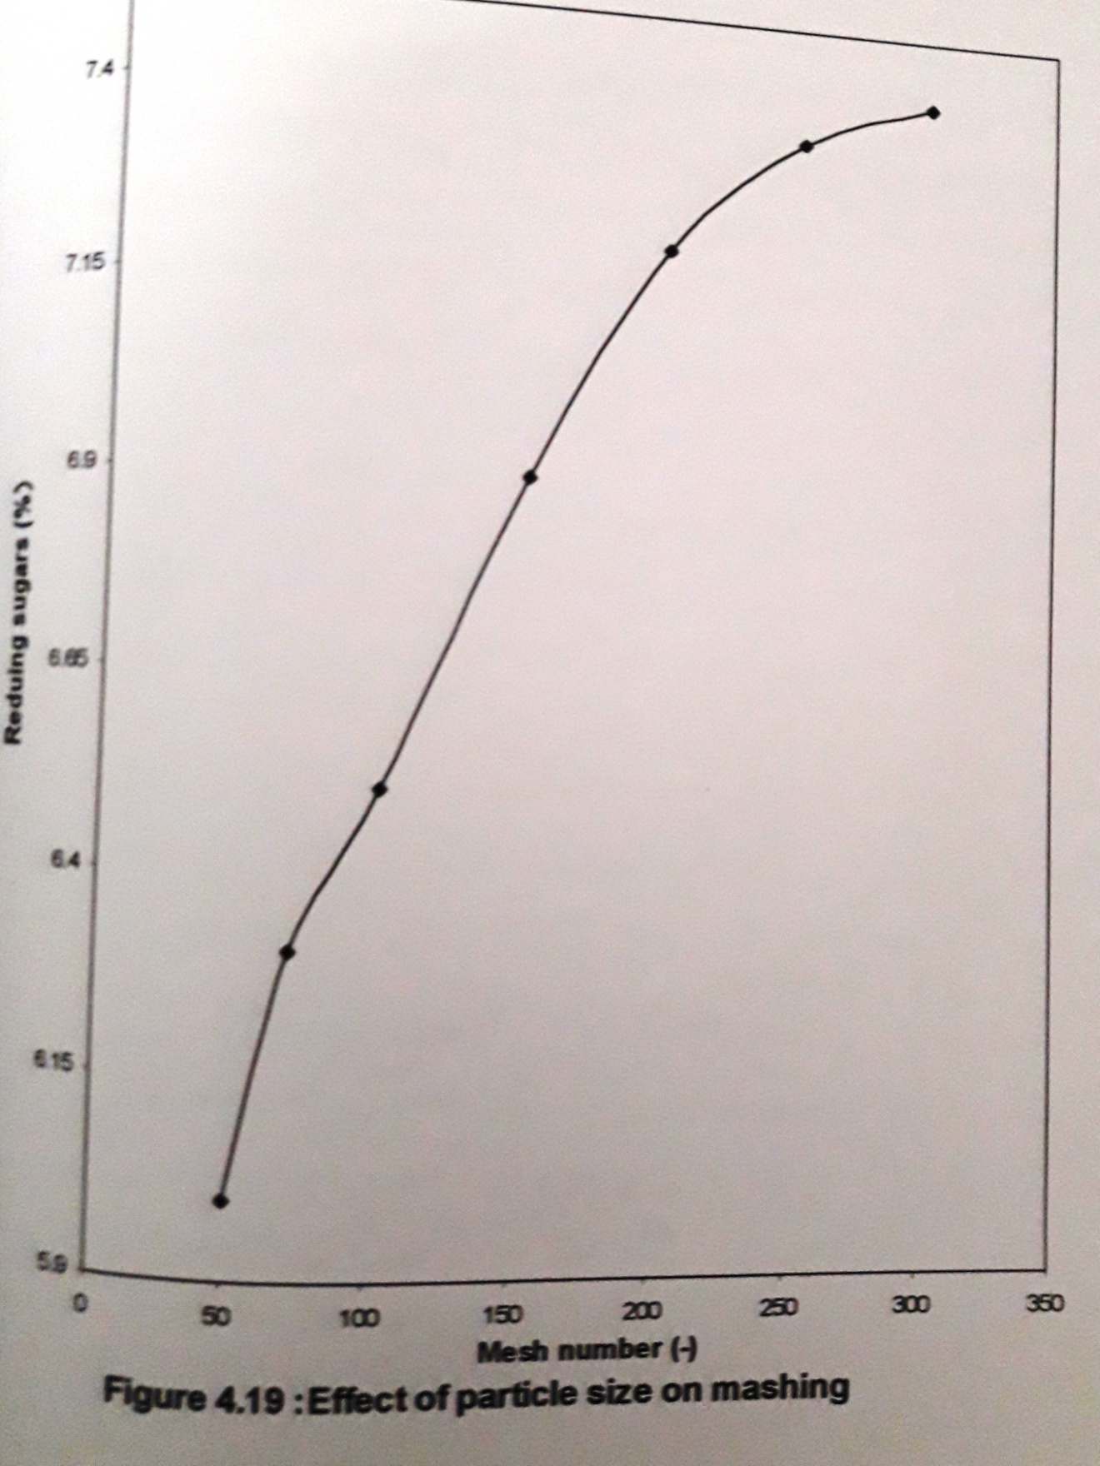

obtained. The increase is steady till -200 +250 mesh size and with further decrease in particle size, reducing sugar formation was less. However, small flour particles resulted in slow wort filtration. Hence this parameter was not incorporated in further studies. Coarsely milled flour was used for further studies.
4.6.2 Effect of flour percentage
The main reason behind using adjuncts is that they provide extract less expensive than malt. Pearl millet flour is used as the adjunct (substrate) for malt obtained from the previous studies. The percentages of pearl millet flour selected for the study are 1.0, 5.0, 10, 15, 20, 30, 35 and 40% (w/v). The flour is cooked in distilled water. To the cooked substrate 2.5% malt was added and incubated at a temperature of 60ºC. Samples were withdrawn every 30 minutes and the mashing process was carried out for 3h.
The decrease in the reducing sugar formation at high flour percentages of 35 and 40 may be due to the low malt concentration used. The malt cannot supply the enzyme concentrations necessary for the satisfactory conversion of the starch to reducing sugars. Another drawback observed with the usage of these high flour percentages is that they formed a very thick dough which contained unevenly cooked starch and it was very difficult to mix them with malt to get uniform distribution of enzymes.
Novellie (1966), studied the mashing with Kaffircorn malt and he observed a steady increase in sugar production up to 20% substrate concentration. In the present investigation a similar linearity is seen up to 20% substrate concentration.

4.6.3 Effect of percentage of malt
The percentage of malt required for efficient hydrolysis of the flour starch is mainly dependent on the malt diastatic activity. The concentration of the malt required for the conversion of 30% cooked substrate was studied by carrying its concentration in the range 2.5 to 12.5 % (w/v) The cooked dough and the malt were thoroughly mixed before mashing. The results at the end of 2nd h of mashing are shown in figure 4.21 with a control having no malt added to it. A drastic increase is reducing sugar concentration was observed upto 5% malt concentration. Later the reducing sugar concentration increase was marginal with further increase in malt concentration. Hence 5% malt concentration was selected and it results in a final reducing concentration of 12.6% by the end of 2nd h.
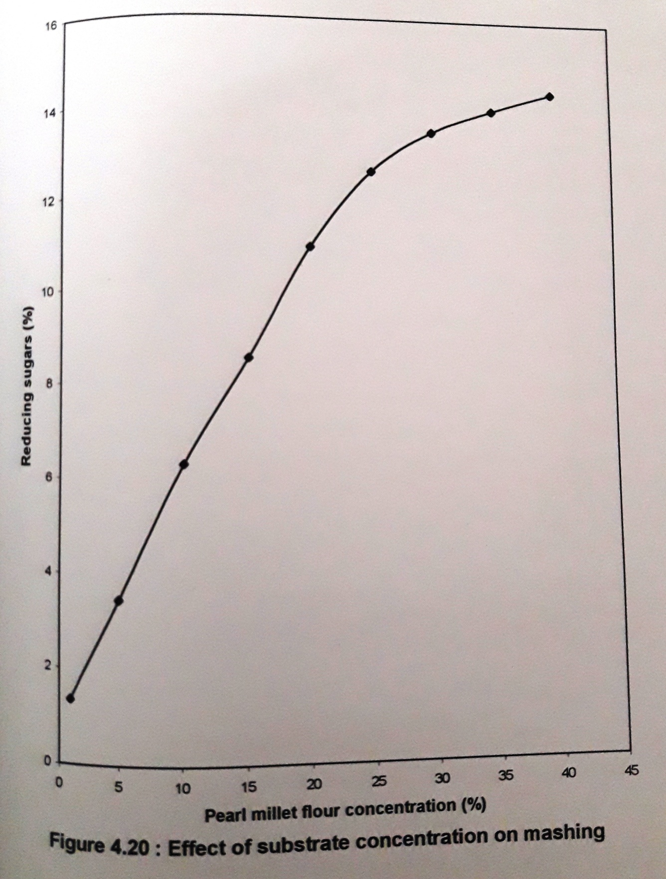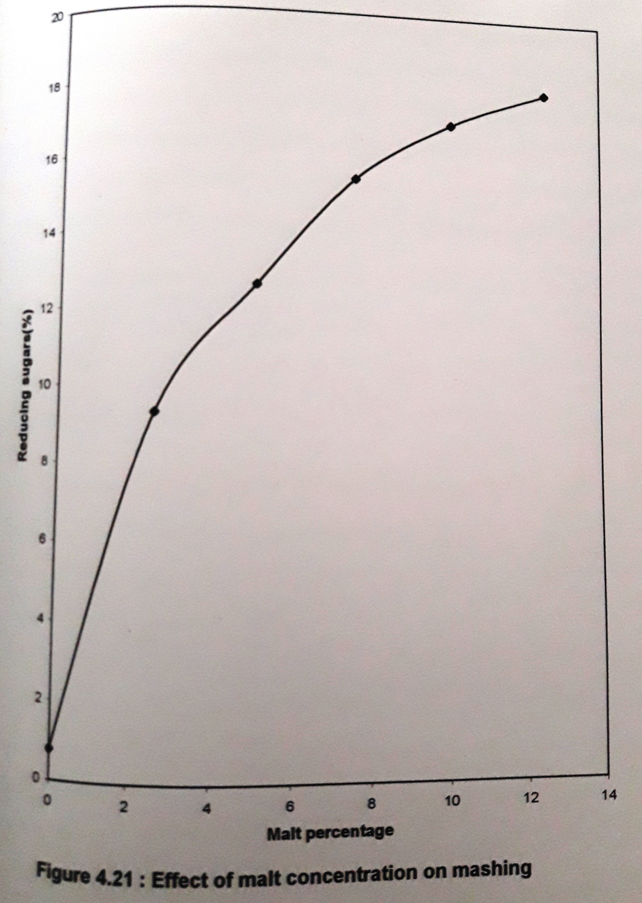
The adjunct to malt ratio is 6.1 which is comparatively less than that used by Novellie (1966) for sorghum beer brewing. Taylor (1989) reported the usage of a ration of 4:1 in the brewing industries of South Arica.
4.6.4 Effect of CaCl₂
Calcium chloride, which is known for its stabilizing properties for amylases, was used in the mashing process. It offers stability to the alpha amylases, when exposed to high temperatures (Kneen et al, 1943b). This concept was once again used in mashing. The concentration of CaCl₂ was varied in the range 0.01 to 0.05% (w/v). Concentrated solutions of CaCl₂ were prepared and approximately 100 micro liters of the solutions were added to the mash to get the desired concentration ranges. The reducing sugars formed after exposure to 60ºC for 3h were estimated. The contents of the mash vessel were mixed occasionally to ensure proper mixing.
4.6.5 Effect of KCl
The activator for alpha amylases selected in the previous study was incorporated during mashing. Its percentage was optimized by varying its concentration in the range from 0.002 to 0.018% (w/v). Concentrated solution of the salts were prepared and then added to the mash to get the desired percentages.
After cooking the starch malt was added and then CaCl₂ and KCl were added and then CaCl₂ and KCl were added. The contents of the mashing vessel were mixed well before subjecting it for mashing. The results of the 3rd h of mashing are plotted in figure 4.23. An optimal concentration of 0.014% KCl resulted in the formation of maximum reducing sugars. Hence KCl at 0.014% was selected for further studies.
4.6.6 Effect of Penicillin G
Penicillin G was added during simultaneously saccharification and fermentation (SSF) studies of potato mash by Renu Agrawal and Sadali C. Basappa (1994). They observed that Penicillin G not only prevented the contamination but also allowed the mash enzymes to be active for a longer duration in SSF studies and hence final ethanol yield has increased. The concentration of penicillin G required to arrest the microorganism of penicillin G required to arrest the microorganism growth, which are present in the malt was studied by varying its concentration in the range 10 to 70U/ml of mashing volume. Figure 4.24 shows the reducing sugars formed. The addition of penicillin G gave very positive results. An increase in the reducing sugar percentage was observed and 50U/ml resulted in 15.1% sugars formation. This is higher yield when compared to the control sample. When 60 and 70U/ml penicillin G were added there is no significant increase in sugars concentration, hence 50U/ml was selected as the optimal value.
4.6.7 Effect of temperature and time of mashing
The effect of temperature and exposure for 3h at that temperature on reducing sugars formation was studied. The temperatures selected for the study are 30, 40, 50, 60, and 70ºC. The reducing sugars formation was monitored at every 30 minutes.
The results were shown in figure 4.25. At 30ºC the percentage of reducing sugars formed was very less. Only beta amylases are slightly active at this temperature. At 40ºC, beta amylases are very active and alpha amylases are slightly active. Hence the sugar concentration is almost doubled when compared to 30ºC. Exposure to 50ºC resulted in 8.5% reducing sugars formation. At this temperature beta amylases are active and alpha amylases are moderately active. Mashing at 60ºC for 3h resulted in 13.5% reducing sugars formation. This temperature is optimal for alpha amylases and hence they are very active. It is unfavorable for beta amylases. Mashing at 70ºC decreased the reducing sugars content. At this temperature denaturation of beta amylases occurs and alpha amylases are moderately active. Hence the reducing sugars concentration is lower than the amount formed at 60ºC.
4.6.8 Infusion mashing schedule
The temperature and time intervals of the US mashing schedule were followed with a very slight modification. The mashing starts at 35ºC to 45ºC and it is mainly done for souring purpose. The rest at 35ºC was done for 20 minutes and then the temperature is slowly raised. No souring will the activity of proteases. The rest at 45ºC for 30 minutes is necessary for the proteases to act. Beta amylases are moderately active at this temperature. Hence, this rest is also known as albumin protein rest.
Mashing between 55ºC and 60ºC is known as the sugar rest. The temperature is optimum for beta amylase, and alpha amylase is moderately active. Proteases are also active at this temperature. The next rest is the dextrinizing rest, which is between 57ºC and 70ºC and the rest is for 35 to 45 minutes. The alpha amylase and the proteases are very active during this rest.
The conversion stage between 70ºC to 75ºC is for a period of 10 to 20 minutes, which depending upon the malt varies. The alpha amylase is very active at this stage. The final mashing – off temperature is usually between 75ºC to 80ºC for a period of 5 to 10 minutes. All the enzymes except alpha amylase are denatured. Alpha amylase retains very low activity.

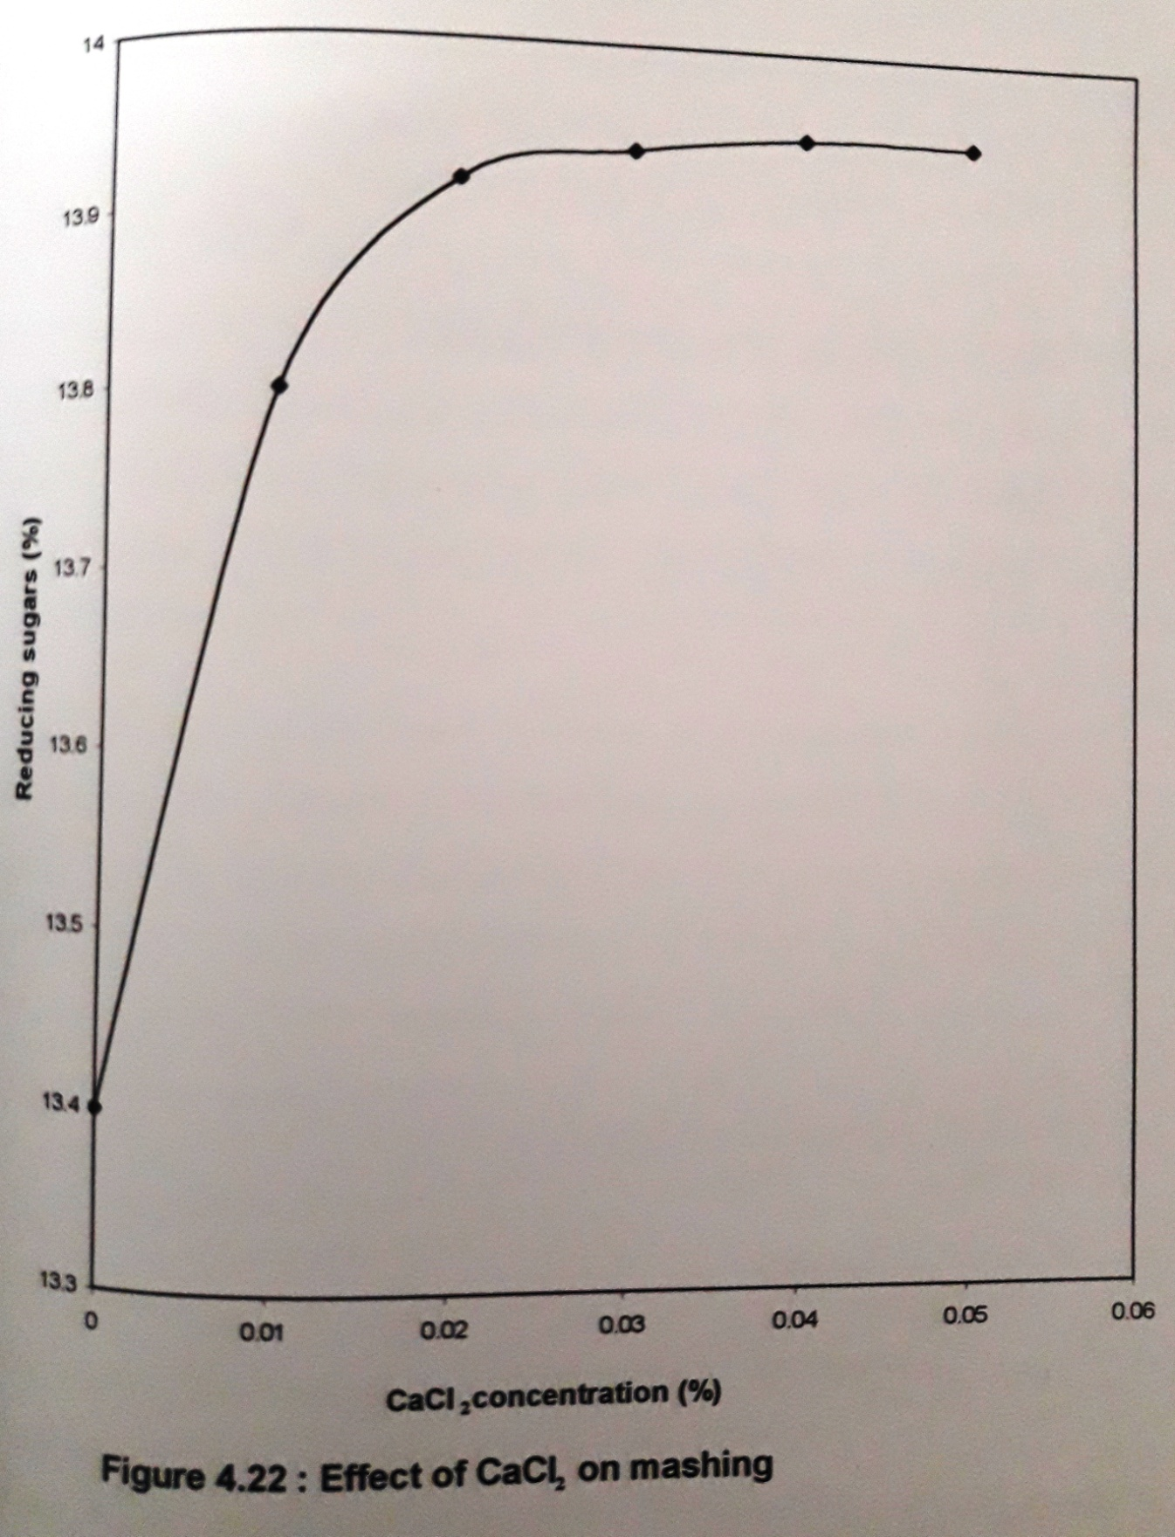

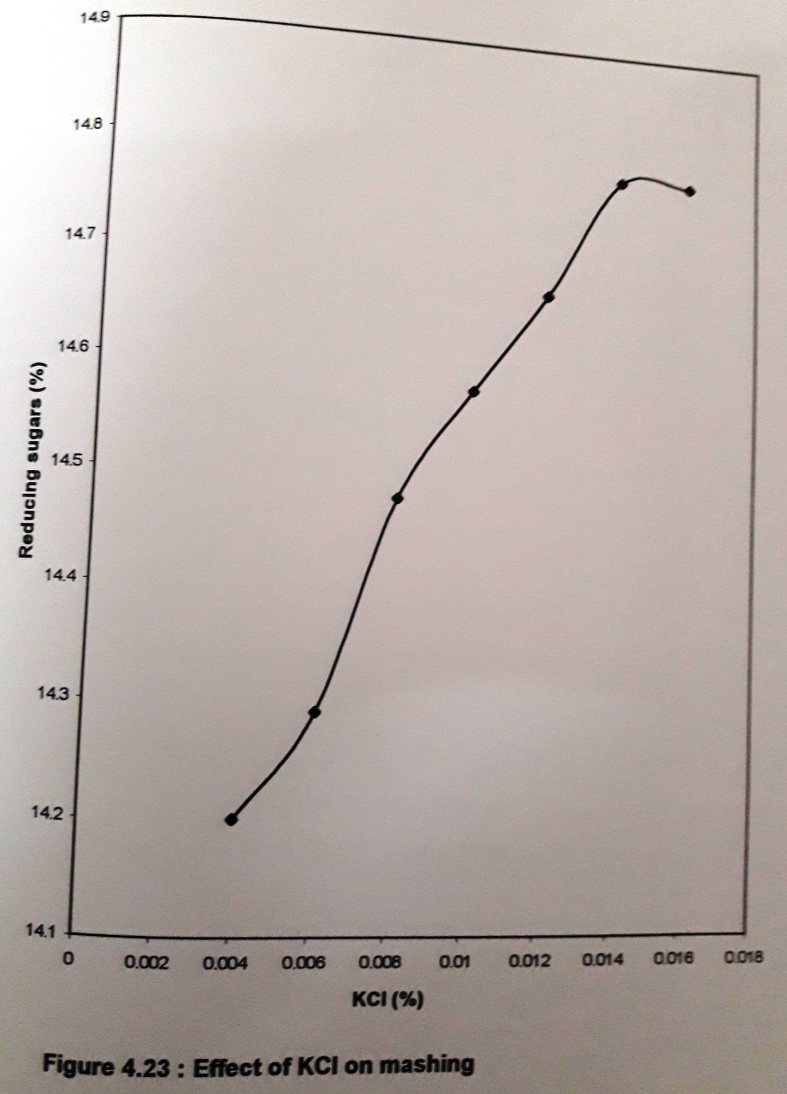

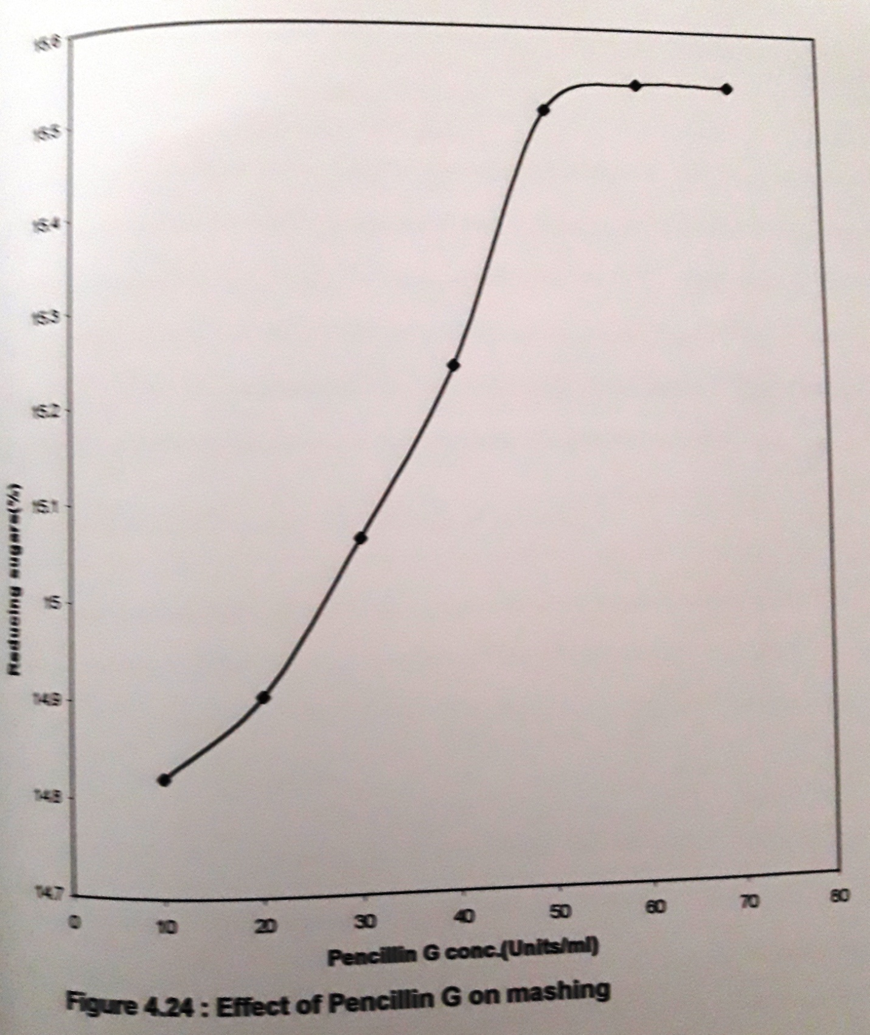

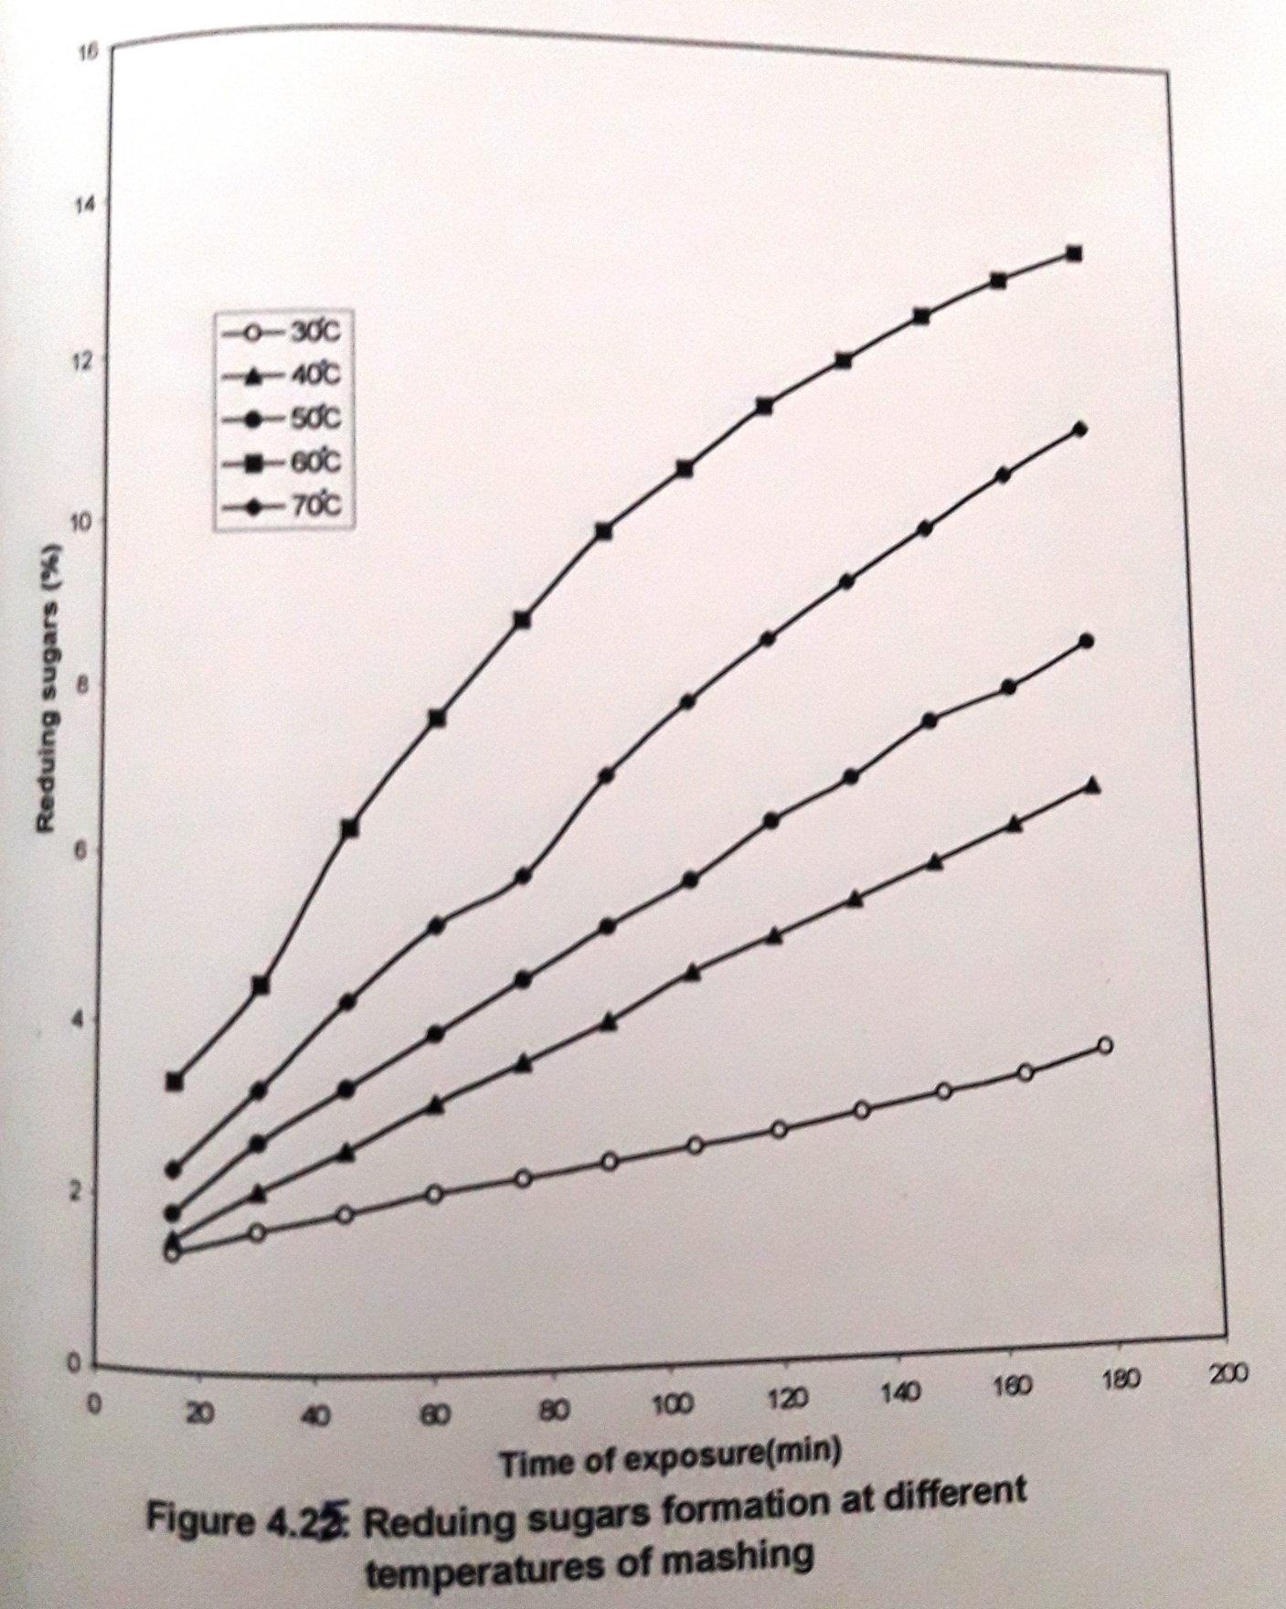

This step is avoided in the present work and the final conversion stage was done for 30 minutes.
Figure 4.26 shows the reducing sugars formed after exposure at respective temperatures as per the mashing schedule mentioned in the previous chapter. The results were also analyzed by paper chromatography. Figure 4.27 shows the pattern of the formation of glucose and maltose throughout the mashing process. The color intensity of the spots increased with time and this indicates that with increase in temperature the rate of release of glucose, maltose and higher dextrins has increased. By the end of mashing 16.81% reducing sugar formation is observed.
Around 84.05% of starch has converted to reducing sugars. The rest of the 15.95% constitutes the higher sugars, i.e., G₃ to limit dextrins and unhydrolyzed starch.

4.7 Fermentation
The mash obtained after mashing for 3.5h was autoclaved to precipitate insoluble proteins and then filtered to get a hazy wort (not opaque and not very clear). This wort is used for further studies.
For the submerged studies, 50 ml of the wort was taken in 250ml Erlenmeyer flasks. The flasks were plugged with cotton and autoclaved at 15lb for 15 minutes. Every parameter optimized was incorporated into the medium before optimizing the next parameter. The autoclaved medium is called to room temperature and then inoculated with the organism. The shake flask studies were carried out in an incubated orbital shaker ( figure 4.28).
4.7.1 Organism
The microorganism selected for the study is Saccharomyces cerevisiae NCIM 3288. Its morphological aspects and the maintenance aspects the maintenance medium were mentioned in the previous chapter.
4.7.2 Optimization of physical parameters
The physical parameters, which effect the ethanol production, are optimized at shake flask level and the results are discussed below.
4.7.2.1 Effect of substrate concentration
The total sugars in the wort were 22%(w/v). As the total sugar content obtained by optimizing the mashing is 22.0% (w/v), the effect of substrate concentration for fermentation of wort studied in the range 4.4 to 22.0%.
Figure 4.29 represents the ethanol produced. The product concentration has increased with increase in substrate concentration and an optimal ethanol concentration of 3.5% was obtained after 48h of fermentation from 22.0% total sugars. The increase in ethanol yield is linear with increase in substrate concentration and hence an optimal value of 22.0% was used in the further studies. For yeast, carbon source (glucose) is the primary substrate for ethanol production. At low substrate concentration, the rate of sugar consumption is reported to be linear (Prit and Kurowski, 1970) and therefore a straight line is obtained. Holzer(1968) reported that when substrate concentrations above 150g/l are used, catabolite inhibition of the enzyme is involved in the fermentation pathway will take place and it slows down the rate of conversion. But this is not found in all yeasts and the industrial strains generally exhibit tolerance to these substrate concentrations.
4.7.2.2 Effect of pH
The fermentation processes are mainly sensitive to changes in pH as it directly affects the rate of fermentation. Most of the distiller’s yeast exhibits activity over a broad range of pH in the range 4.0 to 6.0 (Cysewski and Wilke, 1976b). few can even tolerate exposure to very low pH of 2.0 without permanent damage to the cells ( Hodge and Hildebrant, 1954). In the present investigation, the pH range selected was from 3.0 to 8.0. The pH was adjusted before autoclaving. Figure 4.30 shows the percentage of ethanol produced after 48h of fermentation. The organism exhibited resistance to a wide range of pH, but the rate of fermentation was optimum at pH 5.0 when compared to the rest of the pH values. pH 3.0 and 8.0 have decreased the fermentation rate drastically. The optimum ethanol produced was 4.28% at pH 5.0. The final pH of the medium (2nd day) was checked and it was observed tat in all the flasks it reached to pH 7.0. As ethyl alcohol is a neutral substance, it must have brought down the pH in all the flasks to neutral value. No pH adjustments were done during fermentation at shake flask level. Lower pH values of 4.0 to 5.0 are selected in industrial fermentations to suppress any bacterial contaminations.
4.7.2.3 Effect of temperature
The incubation temperature varies with the selected strain. In the industrial alcohol production, the temperature is usually kept at 30ºC to 32ºC. In the present investigation, the temperature was varied in the range 10 to 40ºC. Figure 4.31 shows the ethanol produced when incubated at those temperatures on the 2nd day.

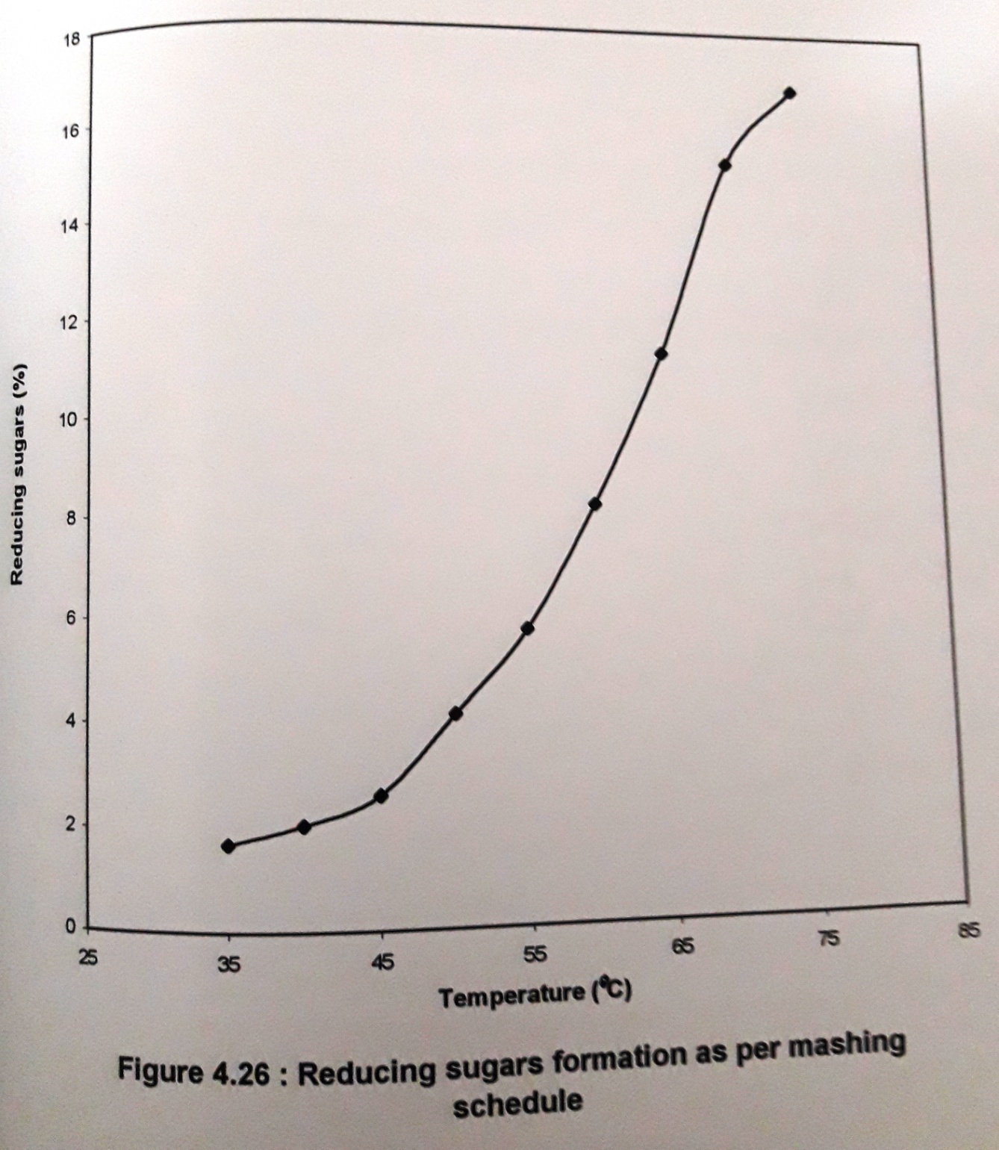
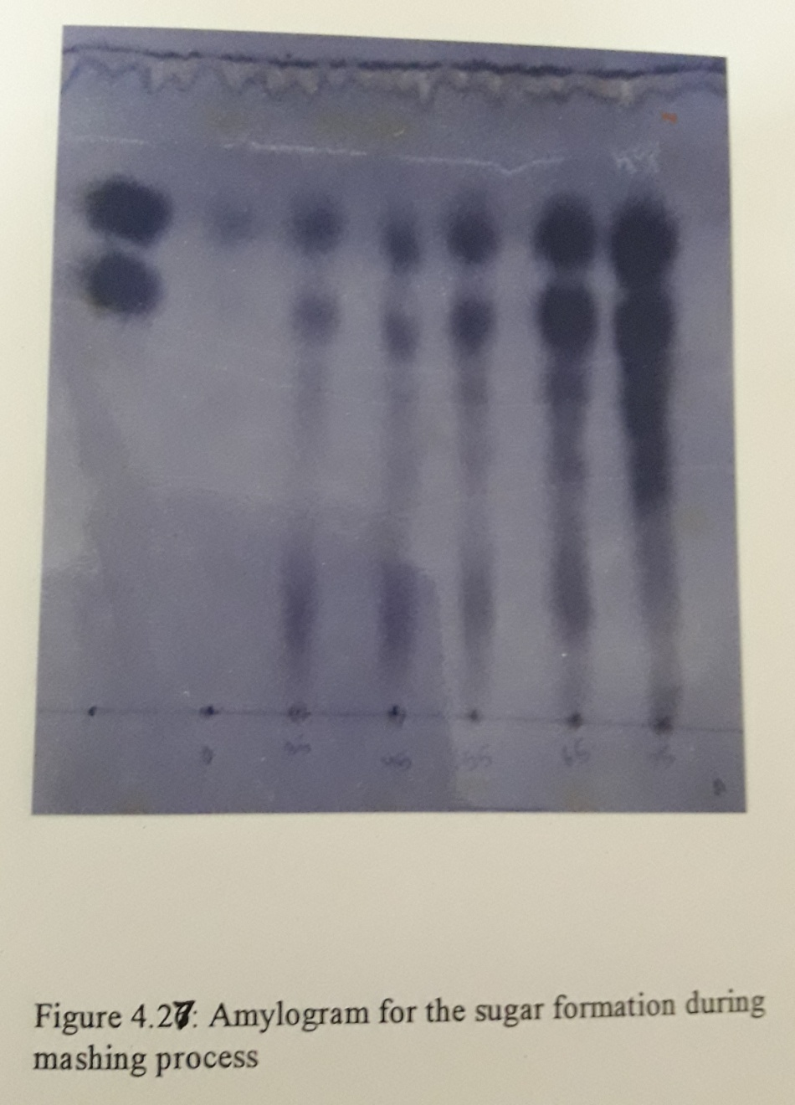

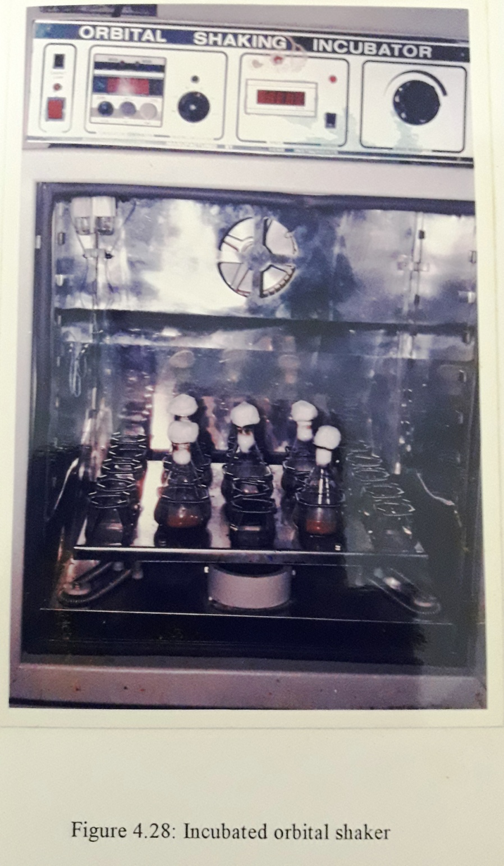

Maximum ethanol yield was obtained at 35ºC on 2nd day. At 30ºC a lower value of 4.3% was resulted and at 40ºC enzymes were inactivated and the yield was very less. At 10 to 25ºC due to the presence of unused sugars the fermentation was still in progress. This may be due to the slow growth rate at low temperatures.
I’Anson (1971), reported that lower temperatures give high final ethanol concentration due to low loss by evaporation, but the time of fermentation increases. Hamba et al (1987), reported that the rate of substrate conversion increases with increase in temperature. Keeping the above observations in view, 30ºC was selected for further studies.
4.7.2.4 Effect of agitation
Agitation provides uniform maxing of the fermentation medium and all the cells will be uniformly exposed to the medium components agitation also helps to remove carbon dioxide produced by the yeast and causes diffusion of oxygen into the medium (exchange of gases). Although ethanol production is generally considered to be inhibited by oxygen, low oxygen concentrations are required by the yeast to maintain cell viability. Dissolved oxygen concentration in the range of 5 – 20 parts per billion was shown to increase the specific glucose uptake rate and specific ethanol production over the rates under strict anaerobic conditions (Grosz Ron, 1987). Excess aeration was also reported to enhance byproducts formation, which include acetate, acetaldehyde and lactate (Bringer et al, 1984).
In the present investigation, the rate of agitation was varied by varying the rpm in the range from 0 to 250. Figure 4.32 shows the ethanol produced on 2nd day of fermentation. At low rpm (0 and 50) the agitation is less and the yeast is not uniformly exposed to the substrate. Optimal ethanol production is observed at 150 rpm. The difference in ethanol concentration is less between 100 and 150 rpm. Excess agitation of 200 and 250 rpm decreased the final ethanol. It may also be due to cell damage but a significant decrease in total sugars is diverted for yeast growth and for formation of other intermediates. The ethanol yield on 3rd day of 0 and 50 rpm was found to be very nearer to the ethanol produced on 2nd day at 150rpm. But the time delay is expensive in any fermentation process; hence 150rpm was selected as the optimal value.
4.7.2.5 Effect of inoculums level
In order to reduce the fermentation time, usually large inoculums of around 10⁷ cells per ml of wort is used. In the present investigation the inoculum level was varied between 1.2 and 8.4 x 10⁶ cells per ml. The ethanol produced on 2nd day of fermentation is shown in figure 4.33. Maximum ethanol production was observed, when an initial cell concentration of 6.0 x 10⁶ cells/ml was used. A maximum ethanol concentration of 4.30% was observed at this inoculums level. Watson and Hough (1966) reported that high cell number in the continuous fermentation of ethanol, though enhanced the product concentration by two fold; the fusel alcohol content has also increased five times. Increase in cell concentration to 8.4 x 10⁷ cells/ml did not improve the final result, as some of the sugars must have been diverted for cell growth.

4.7.3 Optimization of chemical parameters
The organic and inorganic nutrients, which enhance the ethanol yield, were optimized and the results are discussed below.
4.7.3.1 Effect of nitrogen source
All worts contain around 65 to 100mg nitrogen per 100ml, of which only 30 is free alpha amino nitrogen. This low content of nitrogen does not satisfy the nutritional requirements of the yeast. The nitrogen sources selected for the study are (NH₄)₂SO₄, Urea and peptone. The concentration of urea and peptone was varied between 0.5 and 3.0g/l and that of (NH₄)₂SO₄ was varied in the range 0.25 to 1.25g/l. Optimal time observed to attain maximum ethanol production is 36h and the results are shown n figure 4.34 and 4.35. The optimal ethanol concentrations obtained with (NH₄)₂SO₄, urea and peptone are 5.4%, 5.36%. and 5.28% respectively. The variation in the final ethanol yield with the above nutrients was less. Yeast can readily utilize ammonia as the sole source for nitrogen to synthesize their proteins during growth. Urea resulted in a comparatively low yield than (NH₄)₂SO₄. Peptone, which is a complex nitrogen source, does not have any toxic effect, but the product carbon to nitrogen ration is also known to regulate the activity of the glycolytic pathway (Heyse and Piendi, 1973).
In the industrial fermentations of ethanol using blackstrap molasses as the substrate Paturau (1969), used (NH₄)₂SO₄ as the sole source of nitrogen. Peptone, which is a costly nitrogen source and hence cannot be used. Hence (NH₄)₂SO₄ was used as the nitrogen source in the present study.

4.7.3.2 Effect of yeast extract and malt extract
Yeast extract is a water soluble extract form yeast and it contains aminoacids, purines, pyrimidines, vitamins as well as minerals. Malt extract also contains similar constituents. The effect of yeast extract and malt extract in the presence of (NH₄)₂SO₄ was studied by varying their concentration in the range 1.0 to 8.0 g/l.
Yeast extract showed maximum enhancement in the product concentration when compared to malt extract (figure 4.36). The optimal value of yeast extract required for maximum ethanol production was observed to be 6.0 g/l, and the corresponding ethanol produced at the end of 24h is 6.132% (w/v). Malt extract resulted in the production of 5.8% ethanol when added at a concentration of 5.0 g/l. Further increase in its concentration did not increase the final product concentration.
The yeast readily assimilates the purines, pyrimidines and the amino acids and it results in an increased biomass yield (White, 1978). The uptake of amino acids by the cells avoids the cells from using intermediates of sugar metabolism for their growth (Thorne, 1950) and hence the product is also increase. Most of the earlier studies on ethanol fermentation used a mixture of inorganic and organic nitrogen sources i.e., (NH₄)₂SO₄ and yeast extract (Patrice Vienne and Urs Von Stockar, 1983; Maryse Guenette and Zdravko Duvnjak, 1996; Christopher D. Gilson and Adrian Thomson, 1995).

4.7.3.3 Effect of phosphorus
The most commonly used inorganic source of this element is PO₄³⁻. This compound is used as it buffers pH and also regulates the growth of yeast. Phosphorus is mainly incorporated in nucleotides for ATP synthesis and also is an important constituent of genetic material.
The sources for phosphorus selected during the study are KH₂PO₄, NaH₂PO₄, K₂HPO₄, NaHPO₄. Their concentrations were varied between 1.0 and 6.0g/l. The results are shown in table 4.10. K₂HPO₄ resulted in a final ethanol concentration of 6.82%, when supplemented at a concentration of 4.0 g/l. Above and below this phosphate concentration, ethanol concentration has decreased. NaH₂PO₄ also showed a similar trend but was less effective than KH₂PO₄. The other phosphate sources K₂HPO₄ and Na₂HPO₄ resulted in much lower yields than the above two sources. Hence KH₂PO₄ at 4.0 g/l concentration was selected asa the ideal phosphorus source.
Phosphate is mainly assimilated by active transport mechanism (Ramsay and Douglas, 1979). The phosphate concentration is also known to control synthesis of lipids and carbohydrates and in maintaining the cell wall integrity.

4.7.3.4 Effect of mineral elements
The requirement of trace elements for the active growth and fermentation by yeast has been documented by Morris (1958).
Frey et al (1967) studied the toxic effects of copper (Cu²⁺), Iron (Fe²⁺) and other metals. But at very low levels these are not toxic. Certain enzymes need copper for their stimulation. Iron is present in cytochromes and ferredoxins. Iron, Zinc (Zn²⁺) and Manganese (Mn²⁺) are required as enzyme cofactors. Densky et al (1966) reported that 0.05 to 0.1 mg/l zinc when supplemented to the wort stimulated yeast growth. Levels of 500 mg/l zinc were observed to be toxic by Fery et al (1967), Magnesium (Mg²⁺) is known as a activator for many glycolytic enzymes. Potassium (K⁺), Cobalt (Co²⁺), Magnesium (Mg²⁺) and Zinc (Zn²⁺) are considered to be the critical factors for glycolysis (Atkin, 1949; Crane, 1975).
Phosphate is mainly assimilated by active transport mechanism (Ramsay and Douglas, 1979). The phosphate concentration is also known to control synthesis of lipids and carbohydrates and in maintaining the cell wall integrity.

4.7.3.4 Effect of mineral elements
The requirement of trace elements for the active growth and fermentation by yeast has been documented by Morris (1958).
Frey et al (1967) studied the toxic effects of copper (Cu²⁺), Iron (Fe²⁺) and other metals. But at very low levels these are not toxic. Certain enzymes need copper fr their stimulation. Iron is present in cytochromes and ferredoxins. Iron, Zinc (Zn²⁺) and Manganese (Mn²⁺) are required as enzyme cofactors. Densky et al (1966) reported that 0.05 to 0.1 mg/l zinc when supplemented to the wort stimulated yeast growth. Levels of 500 mg/l zinc were observed to be toxic by Frey et al (1967), Manganesium (Mg²⁺) is known as an activator for many glycolytic enzymes. Potassium (K⁺), Cobalt (Co²⁺), Magnesium (Mg²⁺) and Zinc (Zn²⁺) are considered to be the critical factors for glycolysis (Atkin, 1949, Crane, 1975).
In the present investigation the effect of seven metals was studied. The results are shown in figure 4.37 to 4.43. The effect of CuSO₄ was studied by varying its concentration in the range from 1 to 5 mg/l. CuSO₄ (figure 4.37) showed an enhancement effect upto 2.0 mg/l and the concentration of ethanol obtained was 7.06% (w/v) by the end of 24h. Further increase in copper concentration proved toxic to the organism.
The effect of FeSO₄ (Fe²⁺) was studied by varying its concentration in the range of 0.5 to 3.0 mg/l in the presence of CuSO₄. There was a greater enhancement in the final ethanol concentration. It increased form 7.06% in the control to 7.849% when FeSO₄ is added at a concentration of 2.0 mg/l. The ethanol concentration has steadily increased till this percentage and then decreased beyond 2.0 g/l. This decrease may be due to the inhibitory effect of the metal ion above the optimal value.
The effect of Mg²⁺ was studied by supplementing the fermentation medium with MgSO₄ in the concentration range 0.5 to 3.0 mg/l. In the presence of the above two elements already discussed, MgSO₄ showed optimal yield at 2.5 mg/l concentration (Figure 4.39). The ethanol yield has increased from 7.845 to 8.07%. The increment with the supplementation of the metal was slow upto the optimal value and further increase nthe salt concentration decreased product formation.
Effect of MnSO⁴ was studied by varying its concentration in the range from 0.5 to 3.0 mg/l in the presence of the above salts at their optimal concentrations. Mn²⁺ concentration at 2.0 mg/l was found to be effective and the maximum ethanol concentration obtained by the end of 24h was 8.16% (figure 4.40). Effect of ZnSO₄ was studied by varying its concentration in the range 0.5 to 2.5 mg/l. The results were plotted in figure 4.41. The optimal concentration requirements of Zn²⁺ is 1.0 mg/l and the corresponding ethanol concentration has reached to 8.2 % within 20h of fermentation.
Effect of CoCO₃ was studied by varying its concentration in the range from 0.5 to 2.5 mg/l in the presence of the above salts. Supplementation of 1.0 mg/l of Co²⁺ was found to enhance the ethanol yield (Figure 4.42). Further increase in the salt concentration showed an inhibitory effect on ethanol production. The maximum ethanol produced was 8.27 % whereas the concentration in the control was 8.16%.
Effect of CdSO₄ was studied by varying its concentration between 0.025 to 1.0 mg/l. The metal ion (Cd²⁺) showed very little enhancement effect when supplemented at a concentration of 0.05mg/l. Figure 4.43 shows that further increase in the salt concentration proved toxic to the organism. The final ethanol percentage in the fermented wort was 8.312% (w/v) by the end of 20h.
4.7.3.5 Effect of chelating agents
The metal chelators chosen for the study are Ethylene diamine tetra acetic acid (EDTA), Sodium potassium tartarate (SPT) and Potassium ferrocyanide (Ferrocyanide). These were added to the wort before sterilization and the results are plotted in figure 4.44 & 4.45.
EDTA and ferrocyanide were added to the wort in the concentration range 1.0 to 5.0 mg/l. EDTA showed maximum yield of 8.36% when supplemented at 2.0mg/l. But the enhancement in the ethanol yield is very less when compared to the control, which shows that the optimized metal ions added at concentrations, which are non-toxic to the organism. When SPT was added in the concentration range 2.0 to 10.0 mg/l, it showed a very negligible increase of 0.01% ethanol when compared to the control. Similarly ferrocyanide resulted in an increase of 0.03% ethanol concentration than the control value. But the final fermentation time has reduced from 20h to 18h. The control flask showed an optimal yield of 8.21% at the end of 18th h of fermentation.
The reason may be that, some of the metal ions when added before inoculation could be toxic to the initially added yeast inoculums. Hence yeast takes some time to overcome this inhibitory effect. When the metal chelators are added before inoculating, they bind to the metal ions forming a dissociable complex. Whenever the organism starts consuming the free metal ions the complex disassociates releasing the metals for the growth of organism. This might have enhanced the rate of growth of the organism and hence the time of fermentation has dropped down to 18h. EDTA at 2.0 mg/l concentration was selected for the study.
Similar studies were carried out by Kalpana Pandey and Grawal (1993) and by Mu beccel Ergus et al (1997) for ethanol production form cane molasses and sugar beet molasses. EDTA at 50 mg/l was shown to increase the yield when cane and potassium ferrocyanide showed positive effect on sugar beet molasses was sued by Mu beccel Ergus et al (1997).

4.8 Composition of optimized medium
The optimal values of the physical parameters and the optimal concentrations of the chemical parameters are as follows.

The optimized medium (OPM) was used for the reactor studies and fed batch studies.

4.9 Bioreactor studies
After optimizing the medium at shake flask level, the resulting optimized medium (OPM) was used for the reactor studies. Ethanol production is carried out ina 2.0L mechanically agitated stirred tank bioreactor (Biostat M) (Figure 4.46). A working volume of 1.0 L of OPM was used.
4.9.1 Effect of agitation
The rate of agitation of the medium was varied between 100 and 250 rpm. Ethanol production has increased with increase in rpm. The difference in the yield between 200 and 250 was very less. Hence 200 rpm was selected for the study. The maximum ethanol produced at 200 rpm was 8.45% (w/v).

4.10 Fed batch studies.
Fed batch studies were carried out with a final working volume of 1.05 liters. Initially 300ml of the OPM was taken in the bioreactor vessel and sterilized. It is later inoculated with yeast to obtain a final cell concentration of 6.0 x 10⁶ cells/ml of the medium. This used for the determination of the feed intervals.
4.10.1 Optimization of the time for feed addition
The medium after inoculation was allowed to ferment for 16h. At this stage the cell growth is at the stationary phase and the cell growth will start to decline if no substrate is added as evident from its growth curve (figure 4.50). At this stage 250ml of OPM was added. From then onwards he feed is added at different time intervals and the changes in cell number and ethanol production was observed. The feed was added at 3h, 4h and 5h time intervals. The final fermentation volume was fixed at 1.05 L. The feed interval of 3h was found to be effective and it resulted in a final ethanol yield of 8.6 % (w/v) of ethanol by the end of 25h of fermentation.
The date obtained, i.e., changes in total sugar concentrations, ethanol produced and cell number are plotted in figure 4.47, 4.48 & 4.49. The total sugars concentration has decreased to more than half the time the first feed was added in all the studies. Addition of feed at 3h time interval from the time of addition of first feed helped to maintain the cell concentration at its optimal value (40 x 10⁷ cells/ml) (figure 4.49). Intermittent addition of feed though dilutes the cell concentration; the increase in total sugar content after addition of feed increased the cell number. A rapid increase in cell number is observed and therefore the ethanol concentration in the medium has also increased. The final ethanol concentration was comparatively high then the batch studies.
Intermittent addition of feed helps to aerate the medium and also decreases the inoculums levels required and also decreases the toxic effect of metals (if any), hence a higher ethanol yield was observed.
4.10.2 Effect of high inoculums levels
The effect of addition of high inoculums levels of 40 x 10⁷ cells/ml, at 0h and then intermittent addition of feed at 3h time intervals on ethanol production was observed. Figure 4.50, 4.52 and 4.53 shows the changes in the total sugar concentration, ethanol concentration and cell number during the course of fermentation. The total sugars concentration gradually decreased with time and the ethanol produced at the end of 12h is 8.5%. The cell number slightly decreased during the course of fermentation and then increased and again decreased with time.
Addition of high inoculums levels is known to increase the rate of fermentation. The total sugars concentration gradually decreased with time.
The changes in sugar concentration and cell number were monitored before and after addition of feed. During the first three hours, no considerable changes in the cell number were observed. Addition of feed at the first feed interval diluted the cell number and increased the total sugar concentration (figure 4.50). The ethanol concentration was low at this time interval. From then onwards though the cell number has increased after feed addition and fermentation, the increase is comparatively less. The cell number remained lower than the initial cell concentration (figure 4.52). There was a steady increase in ethanol concentration but the final product concentration remained slightly lower than the result obtained in the previous study (figure 4.51).
Intermittent addition of feed dilutes the sugar concentration and its final left over sugars was 4.84%. Wort is a mixture of high molecular weight and low molecular weight carbohydrates. The left over carbohydrates may consist of high molecular dextrins and starch, which cannot be utilized by the organism.

4.11 Comparison of the final ethanol yield
The final ethanol yield ( Yp/s) at shake flask level, Bioreactor and fed batch studies reveal that, fed batch studies resulted in an efficient conversion of substrate to ethanol. The optimal ethanol concentrations obtained during the study were plotted in figure 4.53. Figure 4.54 represents the comparative ethanol yield during these studies. An ethanol yield of 0.5029 was obtained when feed is added at 3h time interval to the production medium at its stationary phase. When high inoculums levels are added, the ethanol yield was found to be 0.4988 which is higher value when compared to the shake flask studies, but lower than the fed batch studies. This may be due to the consumption of some of the sugars for cell growth and its maintenance.
The specific ethanol productivity in the case of fed batch using low and high inoculums levels are 3.44 and 7.08 (g/l/h). It may be noted that though the ethanol resulting concentration has decreased slightly when high inoculum are used, the final ethanol productivity has almost doubled. Hence it may be concluded that the usage of high inoculums levels during the fed batch studies are advantageous.

4.12 Growth kinetics
The present investigation is submerged fermentation of ethanol using Saccharomyces cerevisiae. Figure 4.55 represents the growth curve of the yeast. It may be notices that after the lag phase, there is a rapid increase in the cell growth. The cell number increased rapidly during the exponential phase. The generation time during the initial stages of the exponential phase was less than 2.0h and from then onwards it slightly decreased due to the substrate limitation in the medium. Figure 4.56 represents growth kinetics Saccharomyces cerevisiae. A maximum specific growth rate of 0.5970h⁻¹ was observed.

